AWS Notes

Elastic Beanstalk

Deployment

1. All at once – Downtime while the app is upgraded
2. Rolling – A batch of EC2 instances out of service and gets upgraded and then pulled back in later. Reduced capacity for short period of time. Same EC2 instances are used here.
3. Rolling with Additional Batch – No reduced capacity. New instances that will be used to replace a batch. Attach a new batch and terminate an existing batch. Rollback is difficult and still a manual process.
4. Immutable – Point the ELB to the new ASG with new EC2 instances. Rollback is easy because you do not need to delete the old ASG. Saftest.

Blue green vs in place deployment: Default in place. Blue green happens at DNS level. With blue green, the Route53 point to a new ELB. With DNS, we could have an interruption of service before the DNS changes propagates.

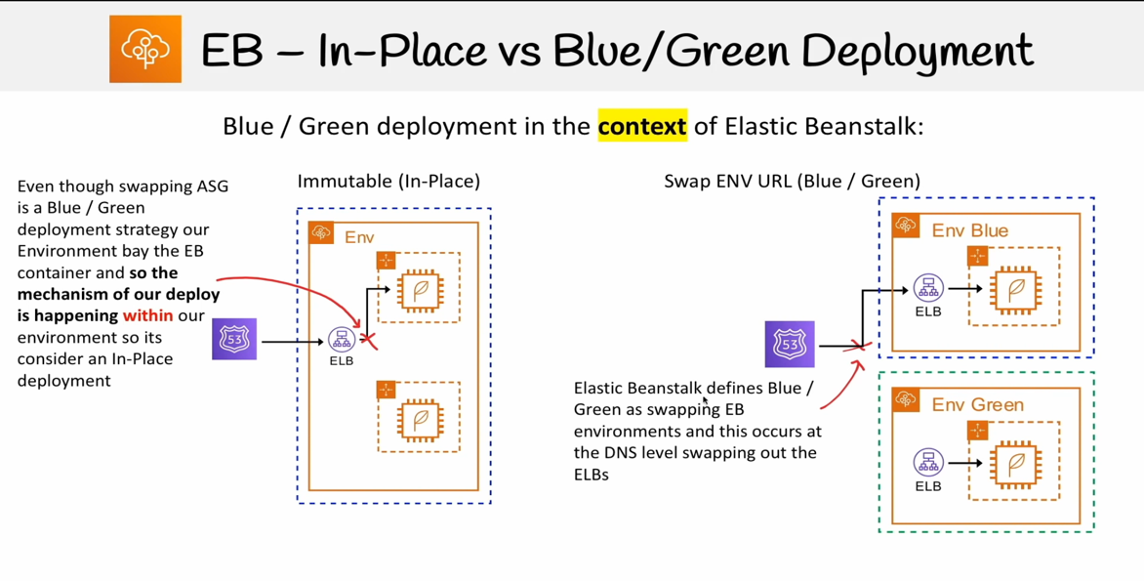

Configuration Files

* .ebextensions folder at the root of the project
* .config is the extension for the config files – a lot of them

env.yaml

* Stored at the root of the project
* Looks at this files and configures some defaults.

Linux server configuration:

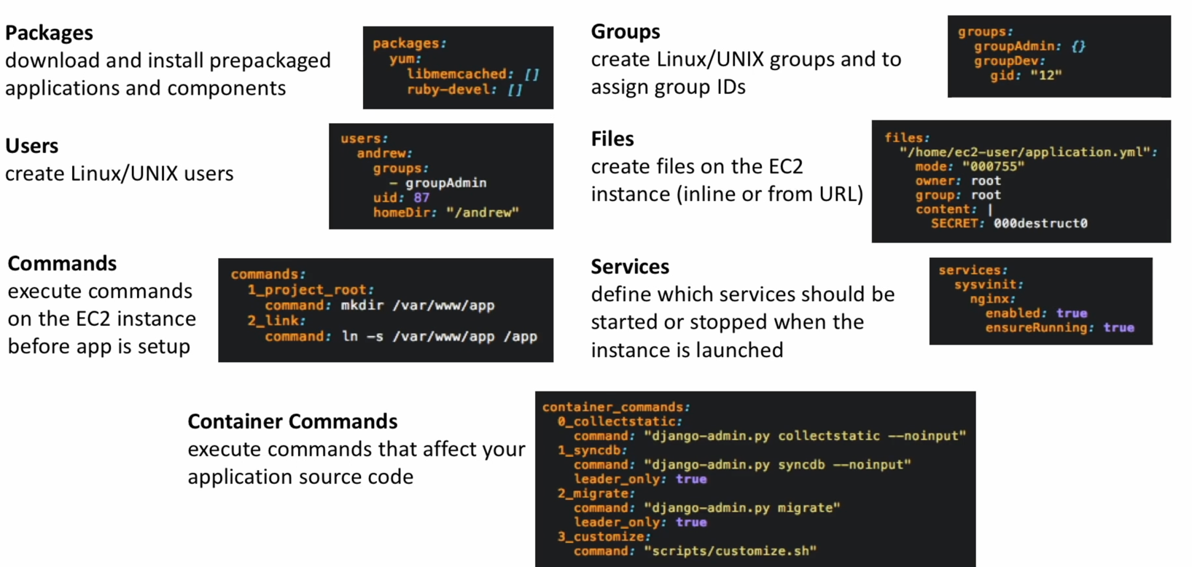

CLI

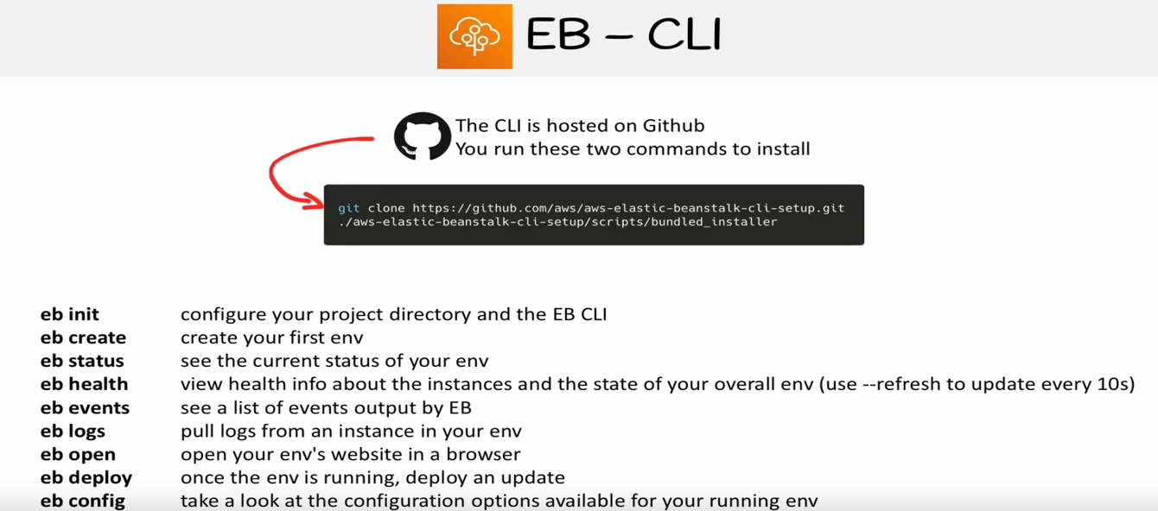

Cloud 9

* A cloud IDE for writing, running and deploying code. Can be used to deploy EB. AWS Management Console –> Find Services –> Cloud9 -> New AWS Cloud9 environment (Create Environment). Select a few parameters like instances etc. and click on Next and and create environment

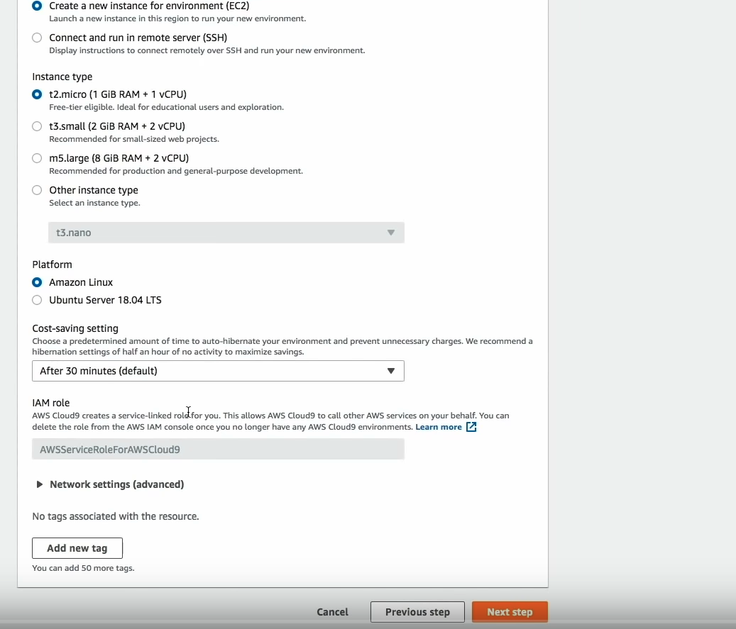

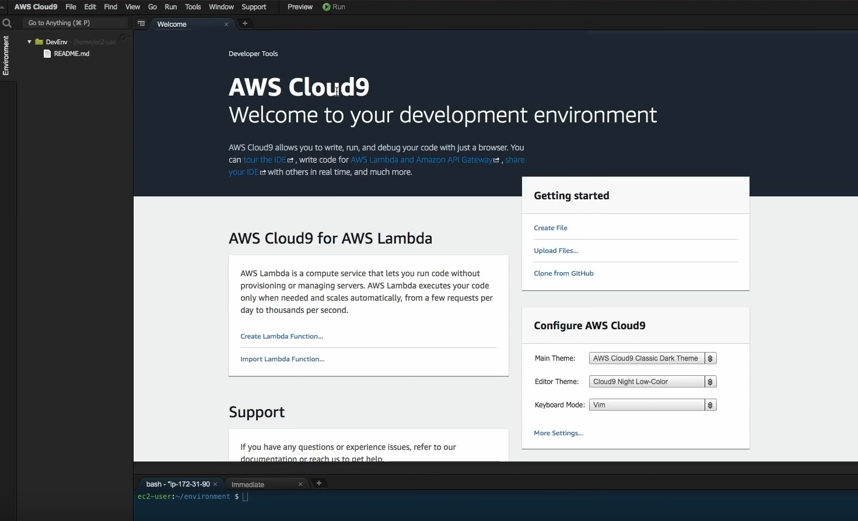

* Install c9.

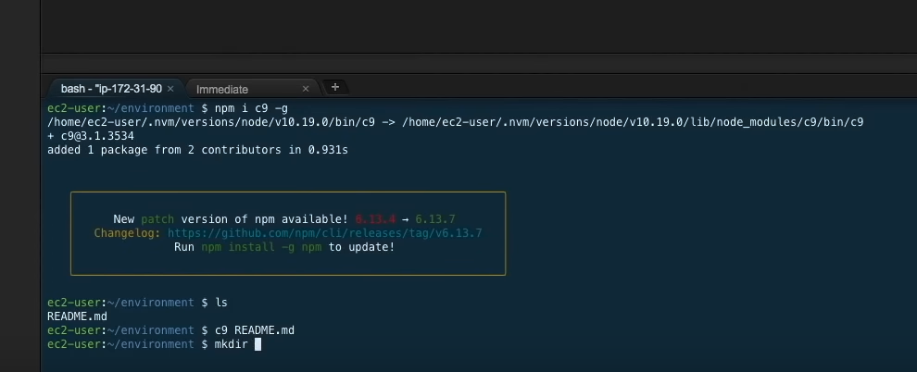

* This has logged in to the EC2 instance. You can add the code, for example a node js application and open up the port using security groups via CLI. You can use the metadata service at 169.254.169.254 to get the security group id associated with the MAC of EC2 instance

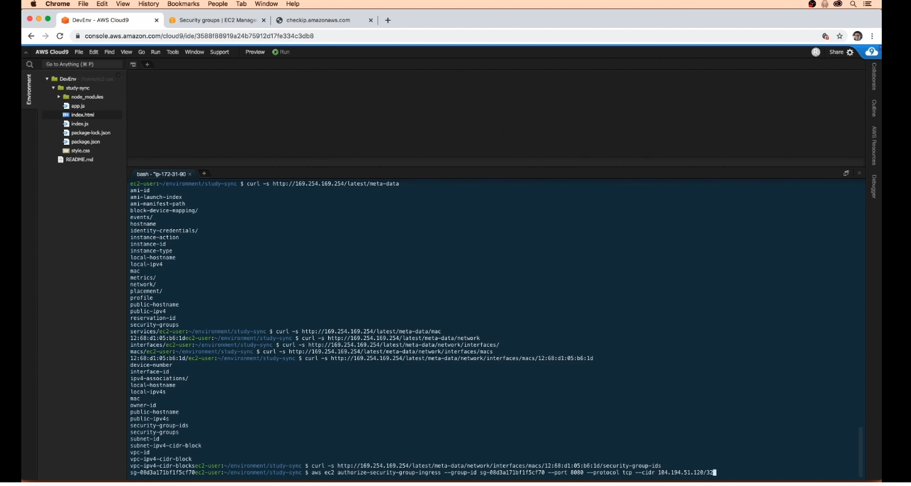

* Now the npm start should start the application locally on that EC2 instance. You can lookup the public IP of the instance using the meta data service and reach it using the browser
* Initialize git repo. Call git init from ~/environment/study-sync folder. Git add, git commit etc
* Setup EB CLI. Look up the instructions on the web.
* Now initialize the EB environment. Be at the ~/environment when you do that. Call eb init. It will ask a few options and can setup the repository in the CodeCommit which is like github within AWS enviornmnet.

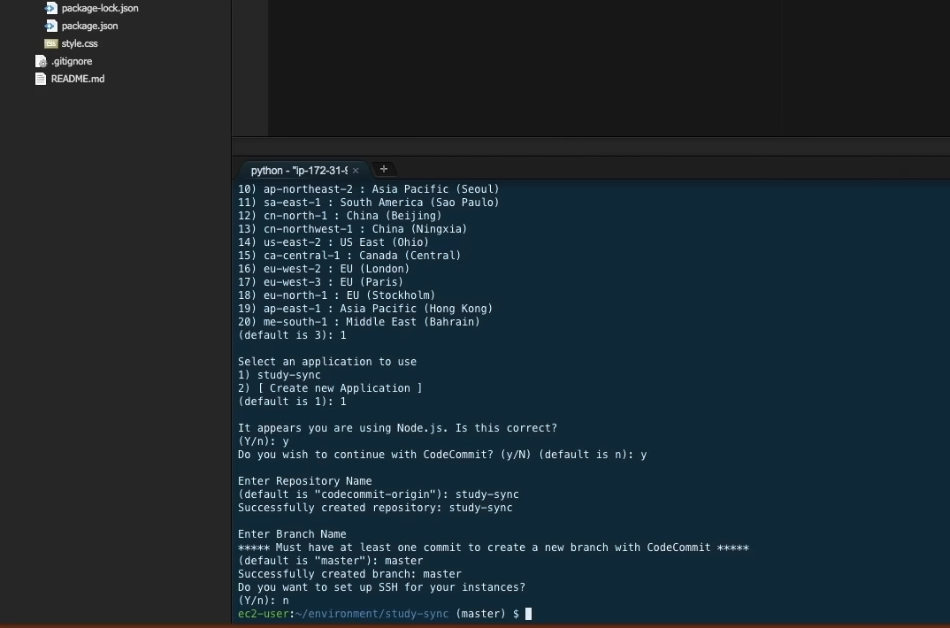

* This should create a hidden .elasticbeanstalk folder. It should have a config.yml file.

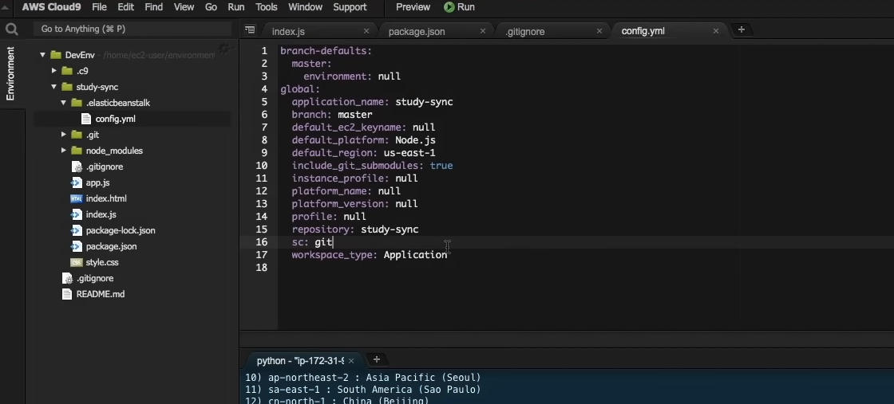

* Next step is to configure the EB environment. mkdir .ebextensions within the project folder and create some config files.

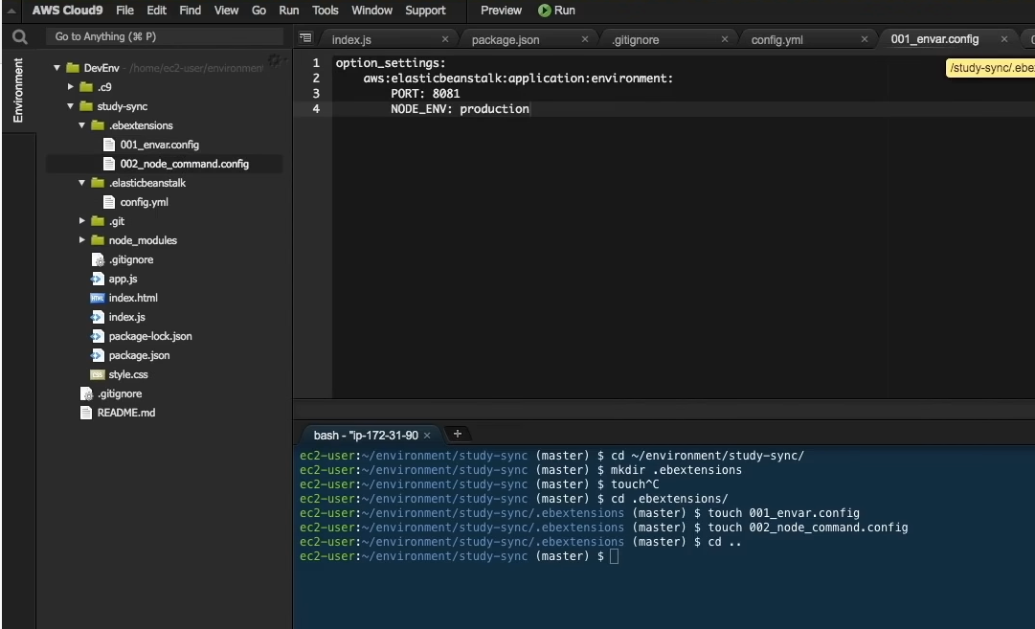

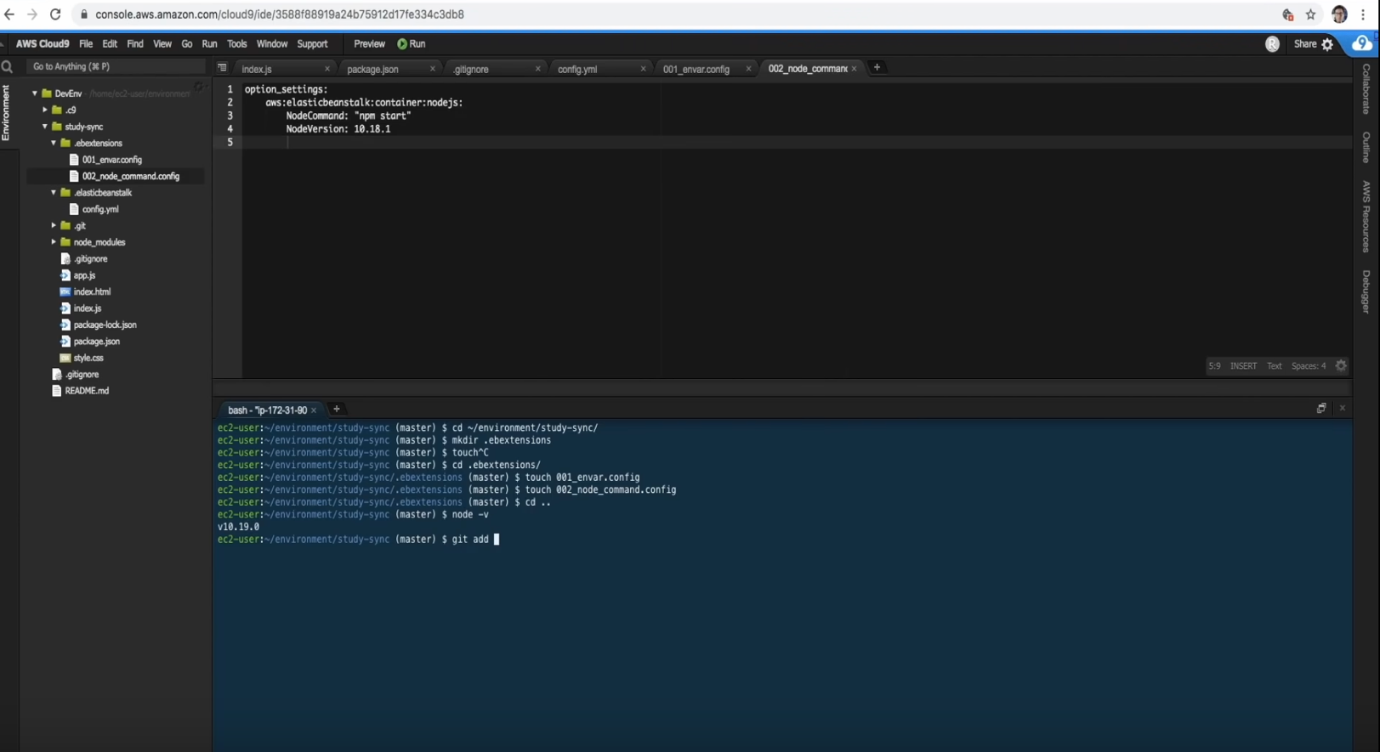

* Commit the configuration files
* Create the environment – eb create - -single for single instance mode otherwise it will spin up a ELB which costs money. Now it will asks us for a few options

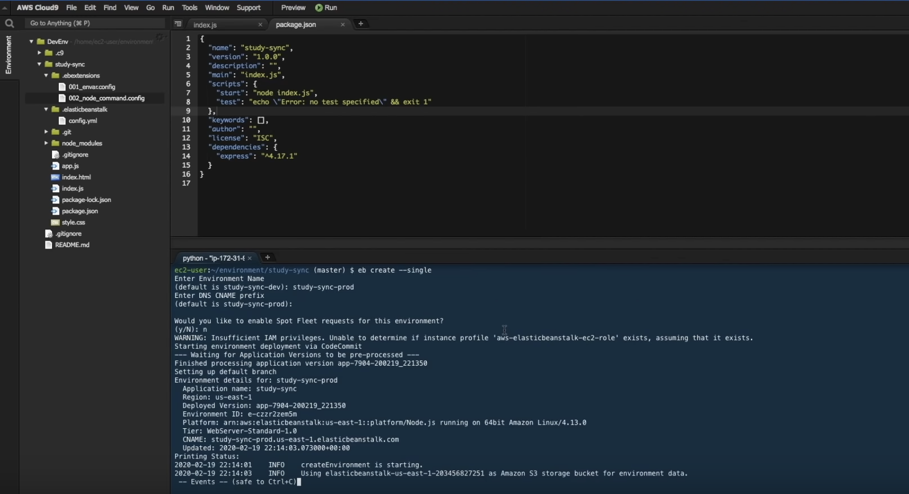

* You can use eb status to check the status for the environment. Environment can also be seen on the console UI.

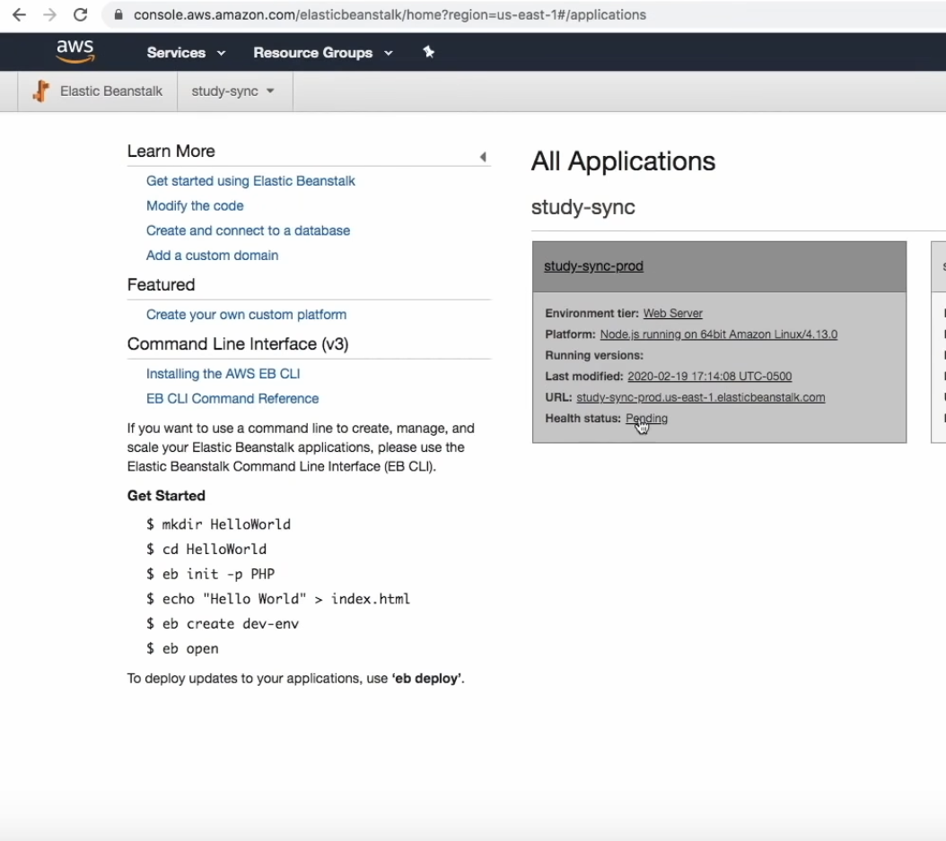

* Sometimes the status could be “Yellow”. Make sure that the right IAM role exists.
* Use eb logs to see detailed logs
* eb status should have the CNAME and the EIP which can be used to access the application

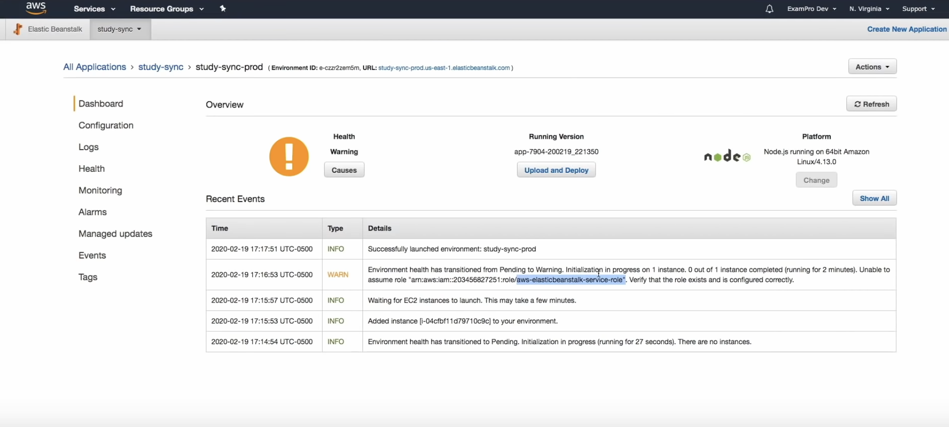

* You can visit UI, click on configuration to change the deployment models etc.

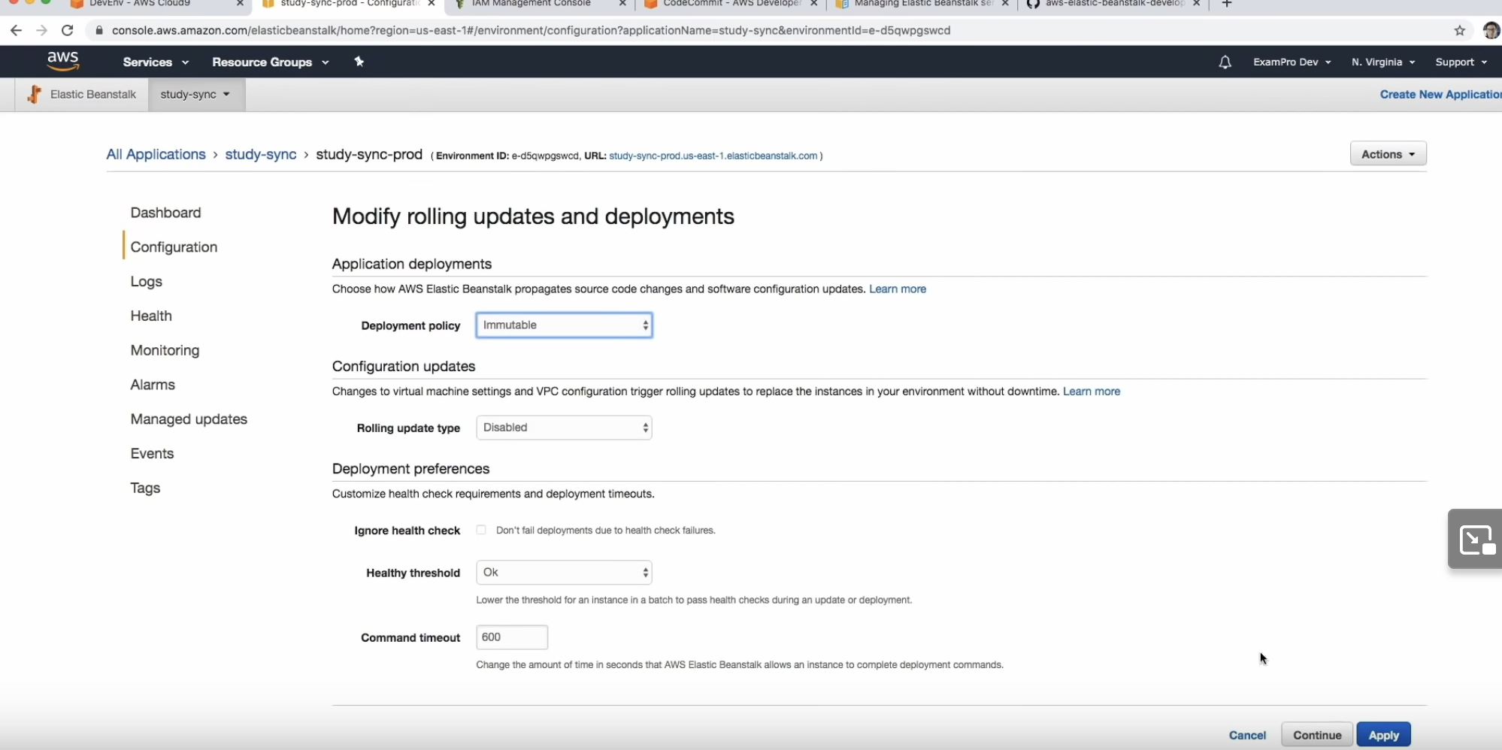

* You can also do that from the IDE. Commit the changes and deploy using eb deploy. If there are some issues, you can use eb abort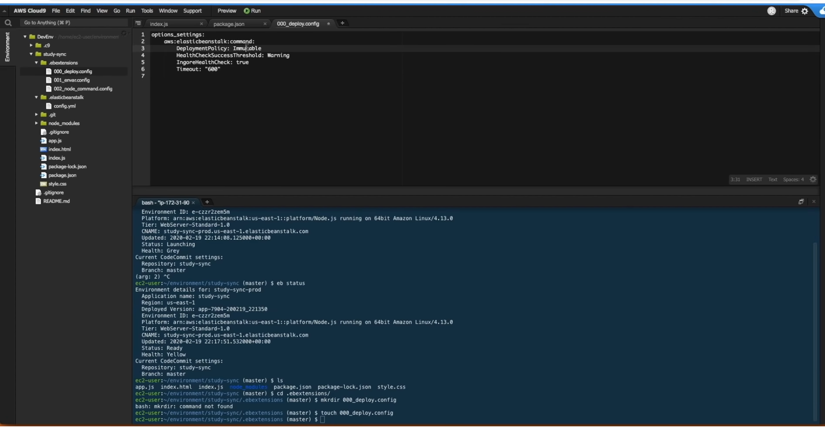
* To start blue green deployment, remove the config file, git commit and eb deploy. This will first switch to All at once.
* Next step is to clone the environment. You can also use eb clone. It should spin up a new environment.

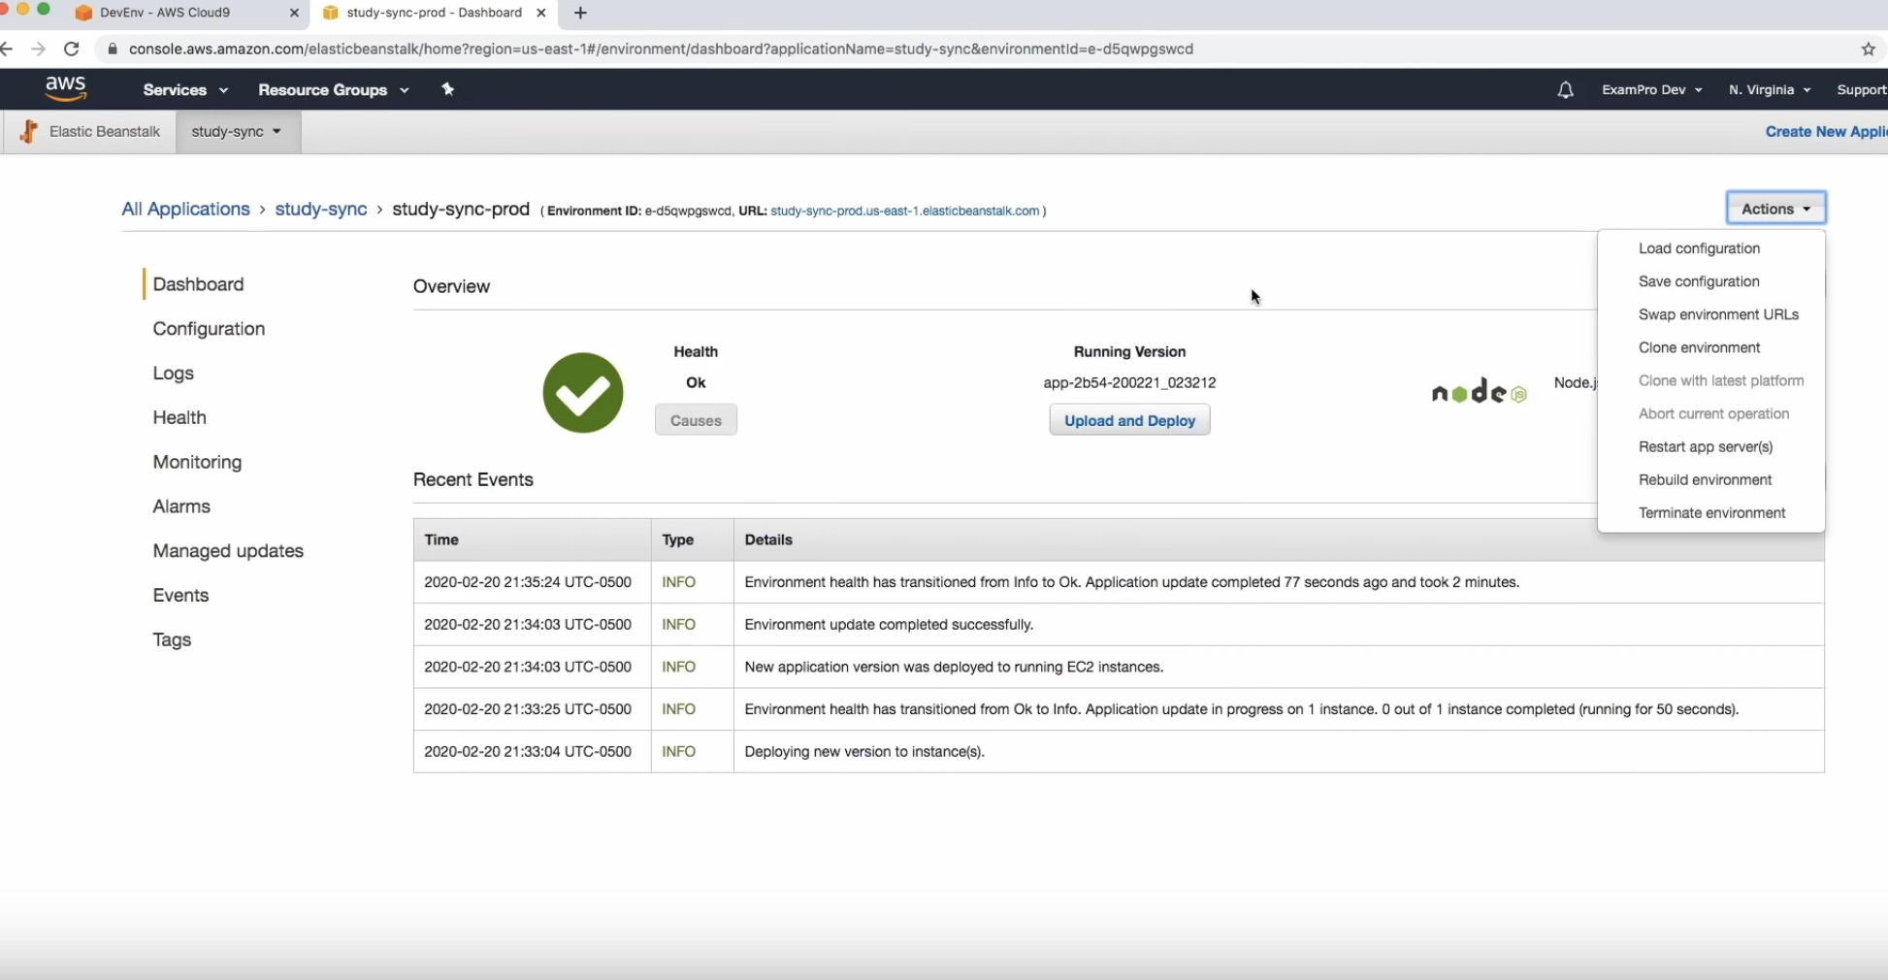

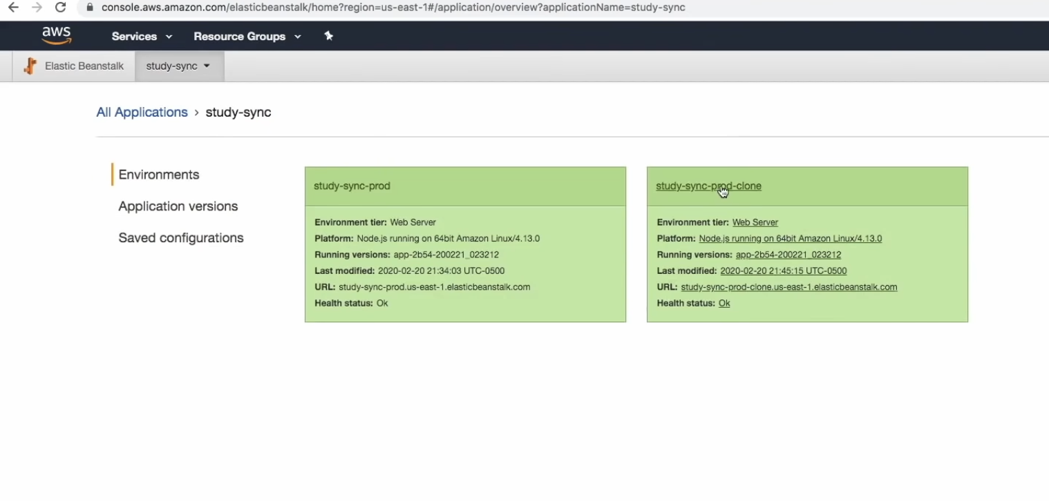

* Now we can make changes to the code. Let’s call it V2. Go to cloud9 IDE, make changes in the ~/environment/study-sync directory and git commit and git push. eb deploy should default to the original environment. So, you should use eb deploy <env-name>. Now you can click on the CNAME for the clone and see the V2 in progress. Now the next step is swapping of the environment URL. You can use the UI or IDE: eb swap -> eb swap study-sync-prod - -destination-name study-sync-prod-clone. Now the CNAME for the original environment on browser should go to V2. We can delete the original environment. eb terminate study-sync-prod. Now next step is deploying a single container docker environment to EB.

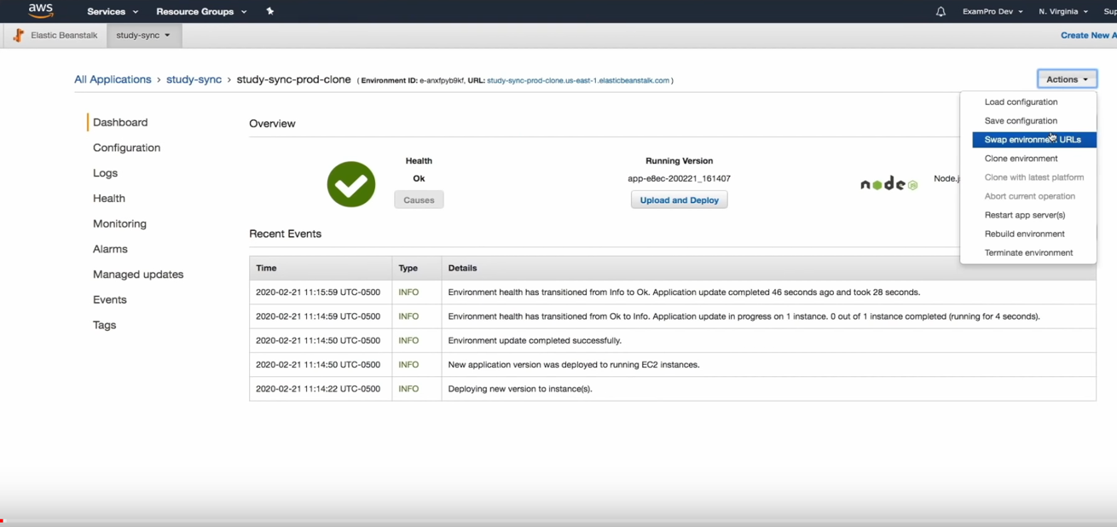

Docker environment on EB

* Create the container containing the application and start it on some port. Example: Here 52.87.226.225 is the public IP of the EC2 instance. There is a Dockerfile here.

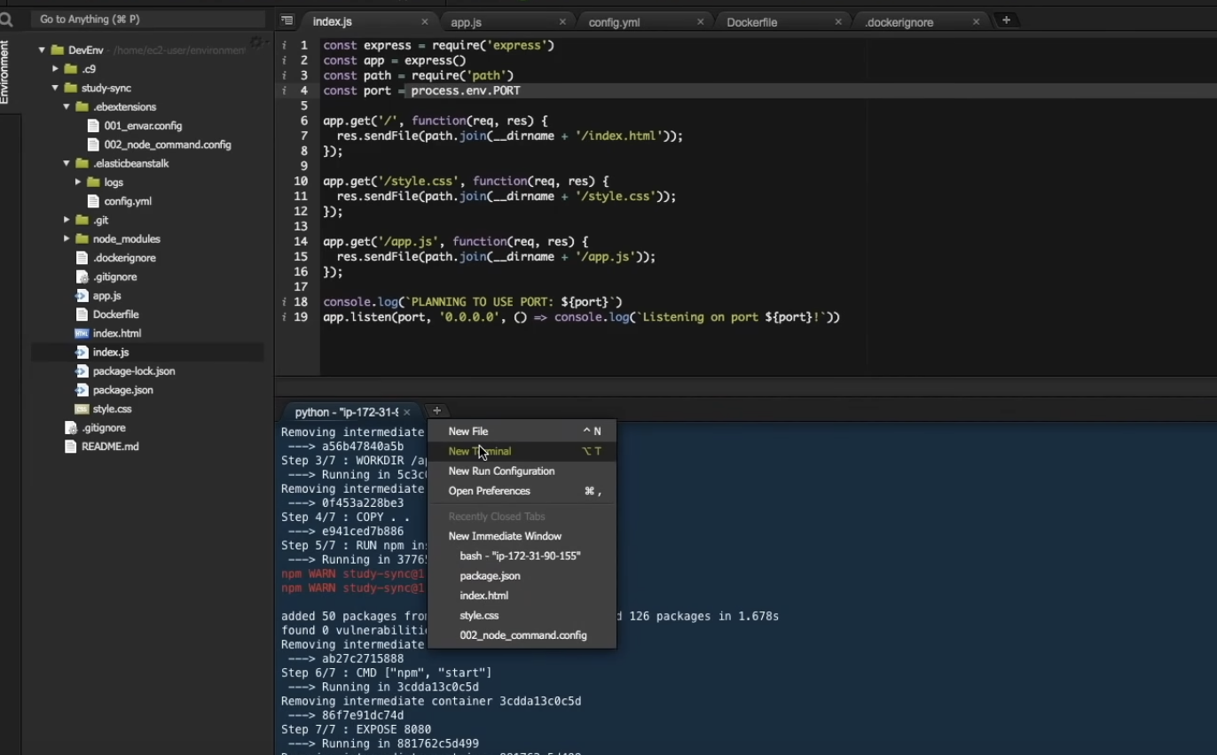

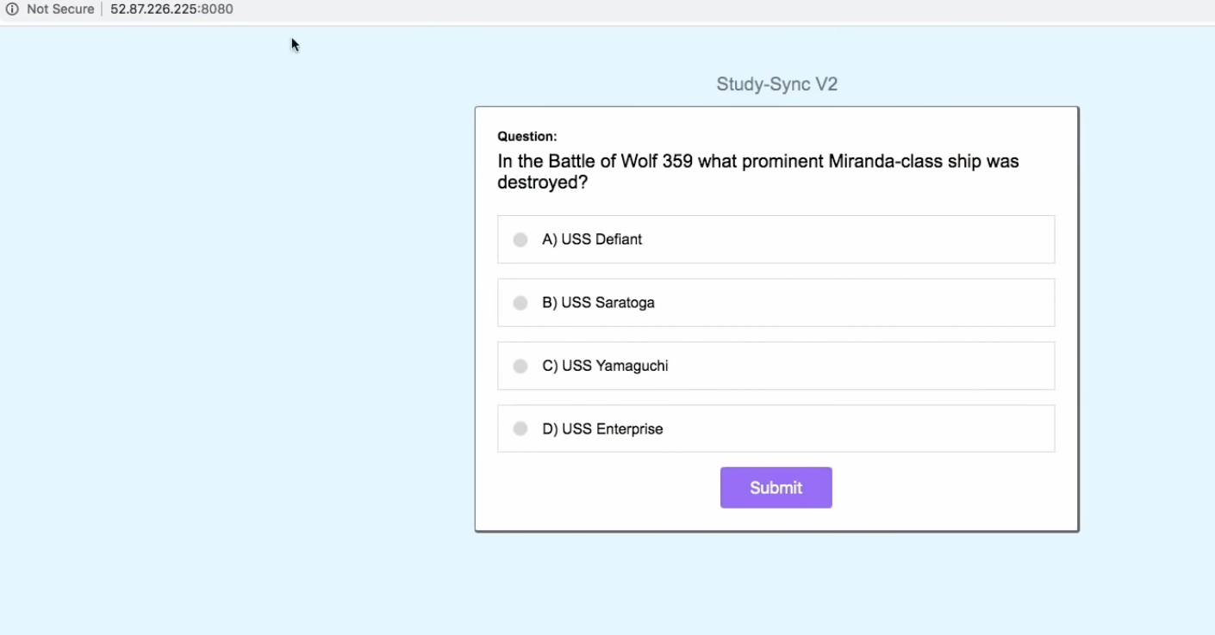

* No need for .ebextensions’s node config files in this case. We still need the environment config files. Just the dockerfile needs to be in the project directory and when you call eb create, the application will be deployed on docker platform. Sample dockerfile

|  |  |  |  |  |  |  |  |  |  |  |  |  |  |  |  |  |  |  |
| --- | --- | --- | --- | --- | --- | --- | --- | --- | --- | --- | --- | --- | --- | --- | --- | --- | --- | --- |
| |  | | --- | | # we'll use 10 since its same as Amazon Linux 1 default node version | |  |  |  | | --- | | FROM node:10 | |  |  |  | | --- | | # where our app will be located in the image | |  |  |  | | --- | | RUN mkdir -p /app | |  |  |  | | --- | | WORKDIR /app | |  |  |  | | --- | | # move all source code | |  |  |  | | --- | | COPY . . | |  |  |  | | --- | | RUN npm install | |  |  |  | | --- | | CMD [ "npm", "start" ] | |  |   EXPOSE 8080 |

* Typically you create the docker image and push it to the registry (ECR). docker build -t study-sync . .Authenticate to ECR. You can find the user id in IAM console.

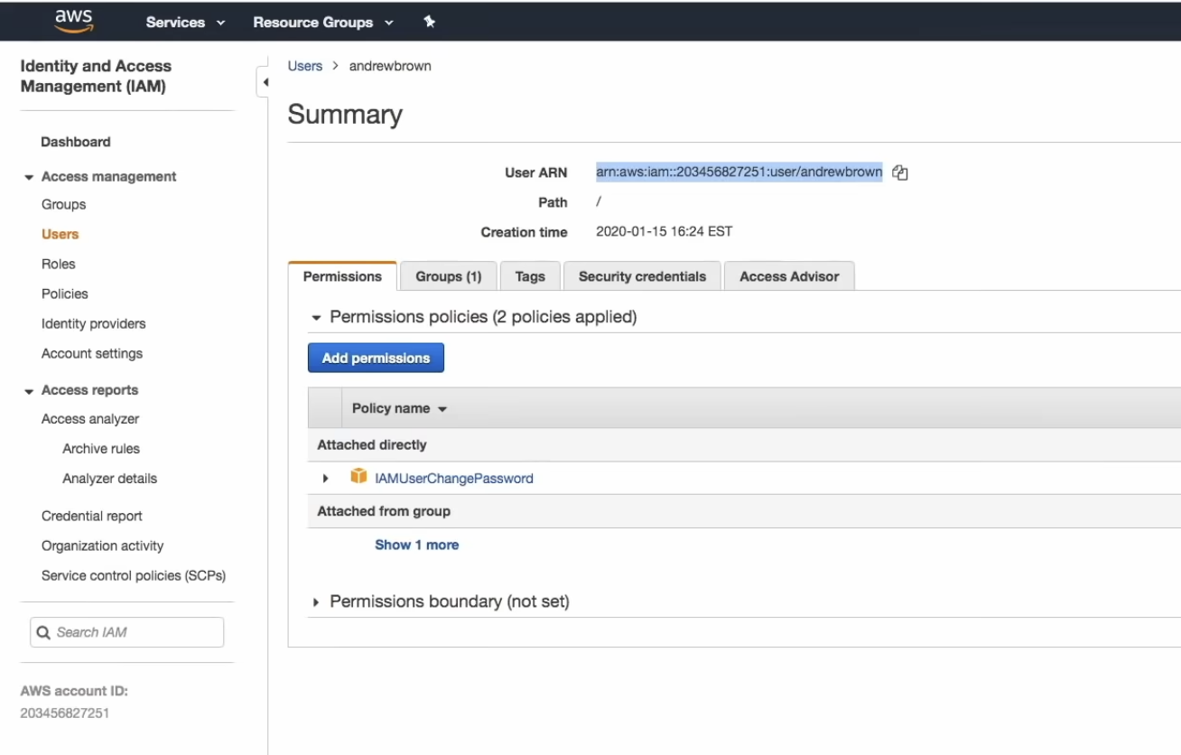

* Run the following command to authenticate to ECR. aws get-login-password | docker login --username AWS –password-stdin 203456827251.dkr.ecr.us-east1.amazon.aws.com. The config.json file generated will have the token. 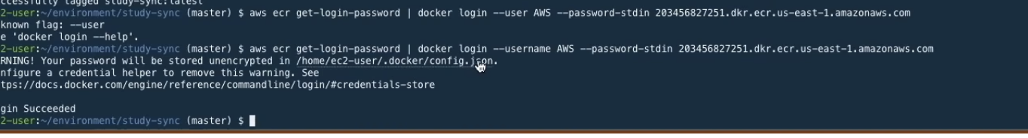
* Tag the image

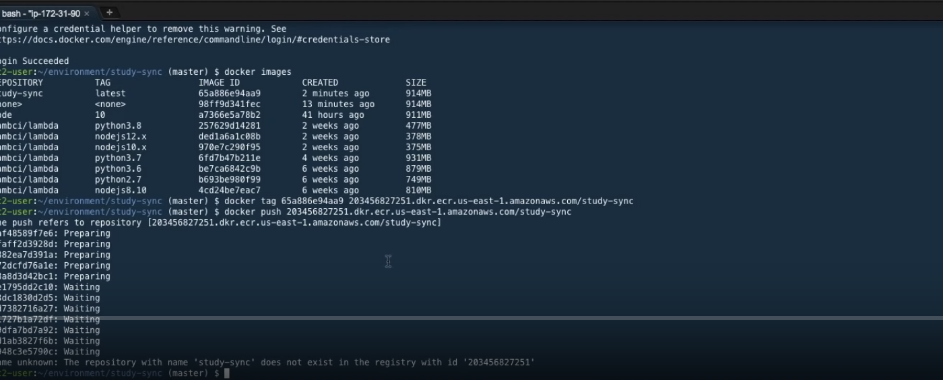

* Create the repository on ECR

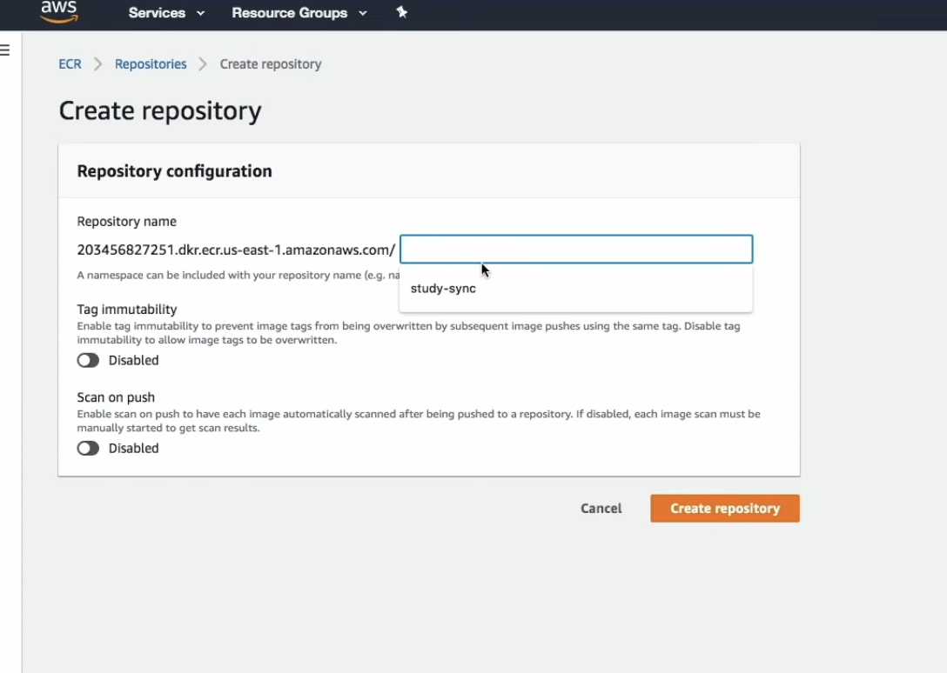

* Create a new folder in environment and create Dockerrun.aws.json file. Define the docker version in that file. 1 for single container and multiple for multi containers. Specify the image name, port here. Copy over the old .ebextensions and .gitignore file to the new project

folder study-sync-external. You may need to call git init as well. git add, commit. Then eb init. Same steps. Select Docker as yes.

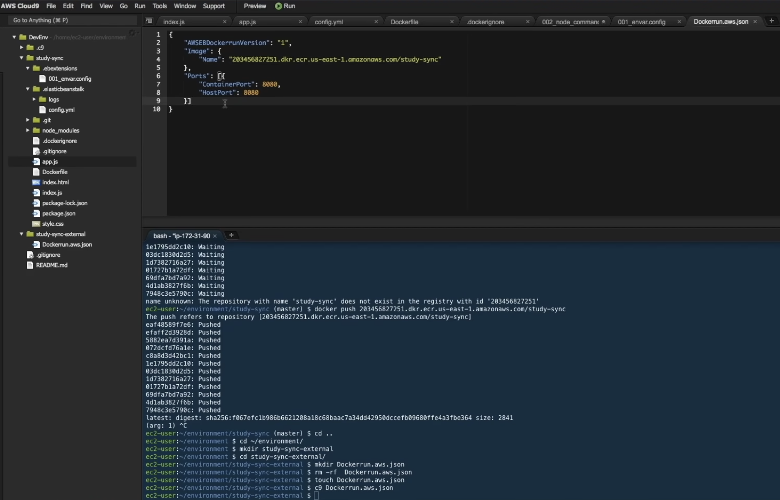

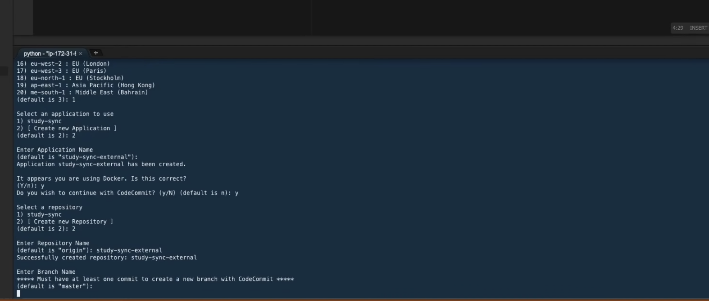

* You can check the new repo is created. Now you can call eb create –single

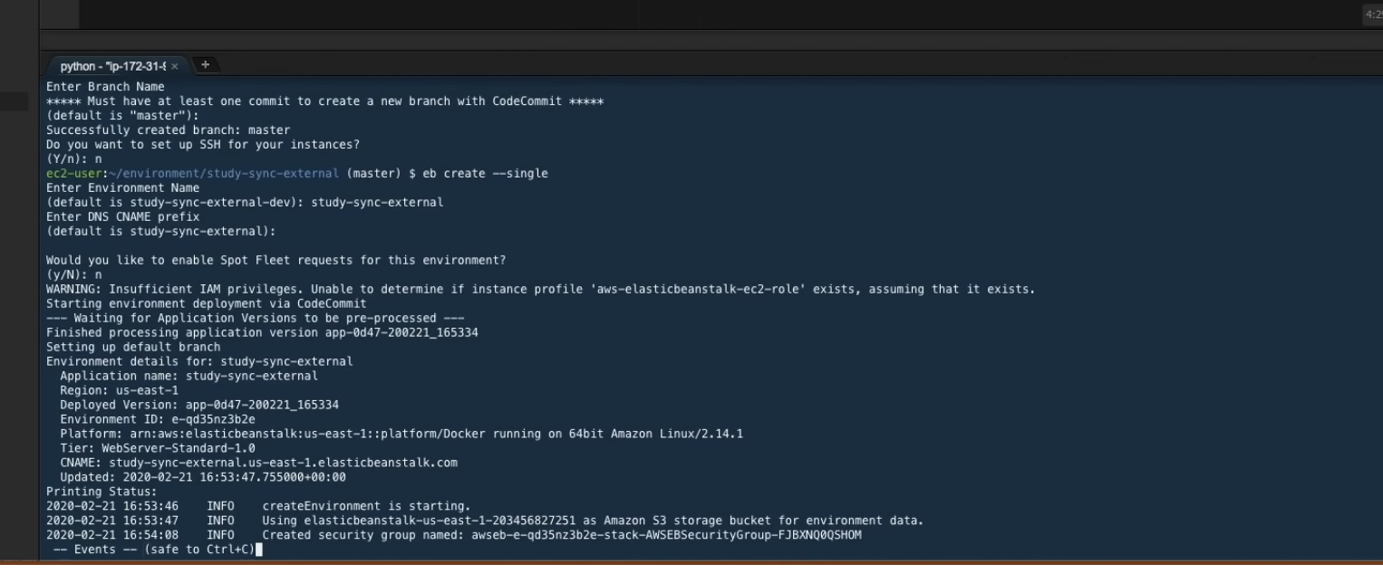

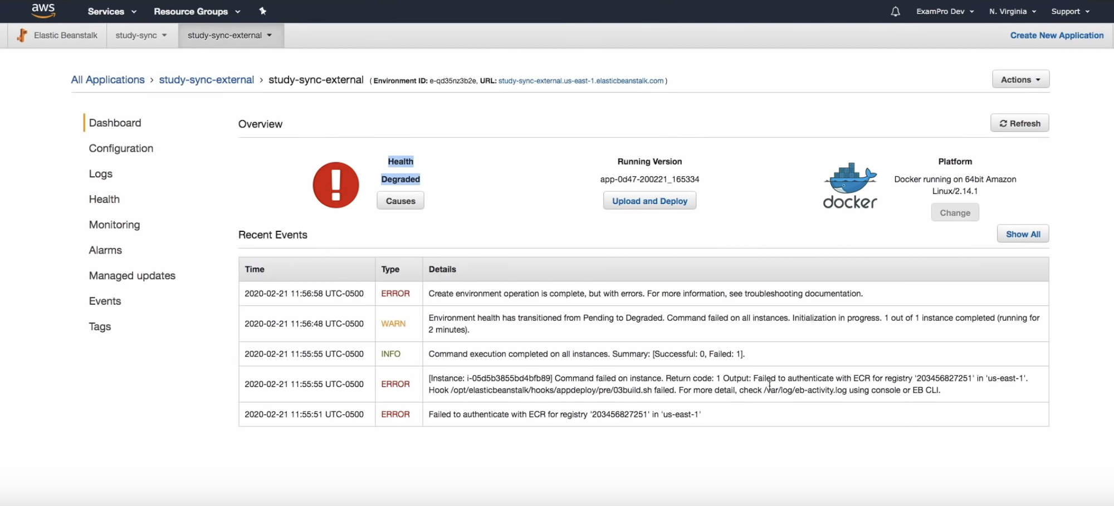

* Fix the errors regarding authentication. EB needs to authenticate to ECR. In the cloud9, all the credentials were stored in the config.json file. So the previous project study-sync-docker (Dockerfile approach) was able to run using eb create. Now with the image approach, we need to update the instance profile of the EC2 instance that runs in EB. Go to IAM and then roles. 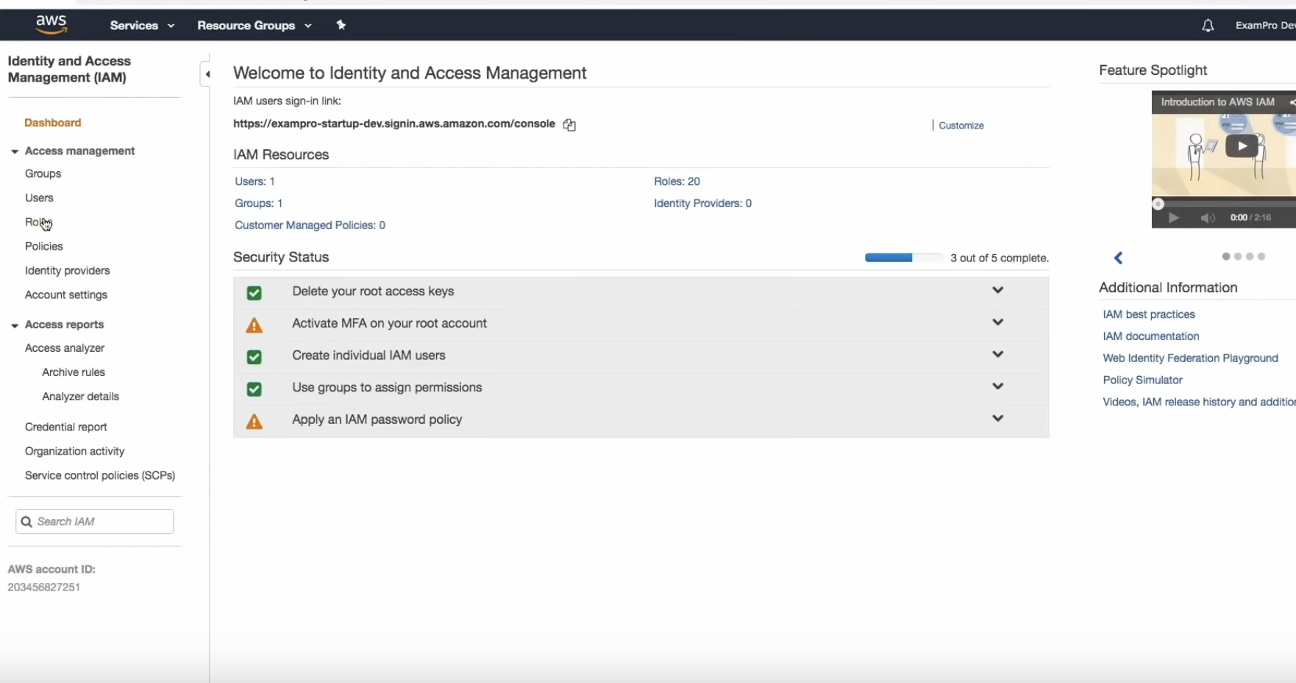

Go to elastic bean stalk specific role and attach permissions

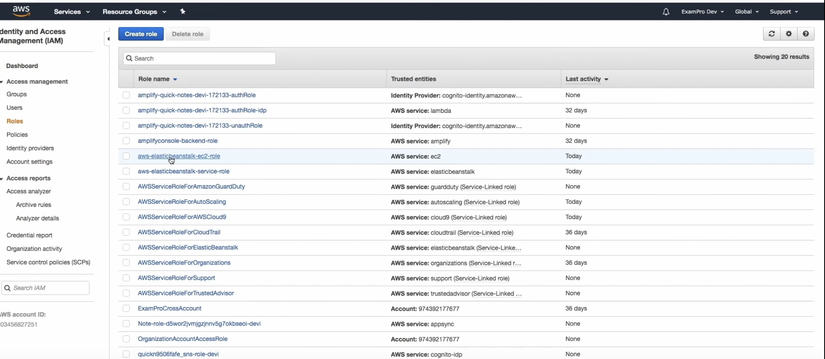

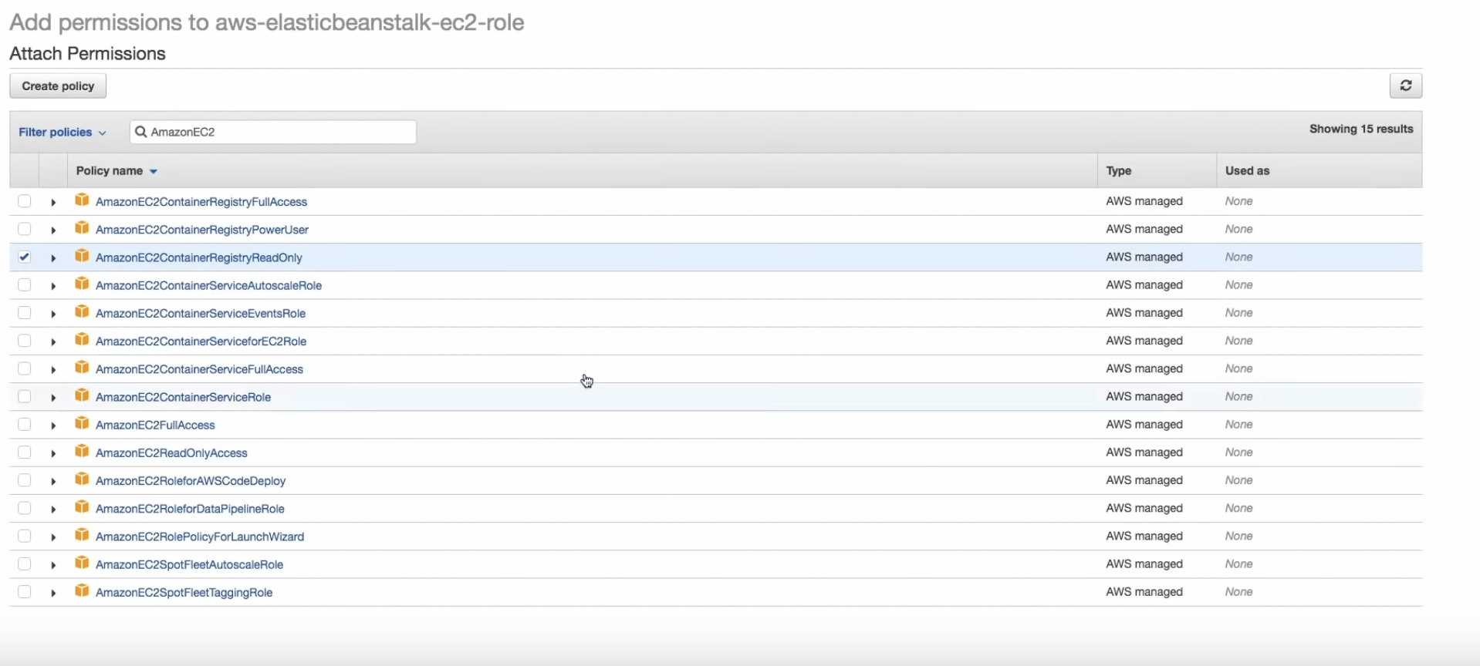

Now you can go back to cloud9 and call eb deploy.

* To summarise, in the non docker approach you create config files which have the node command for example to start the application. In the docker way, you have the Dockerrun.aws.json file which is used when eb create is called.

ECS

* Elastic Container service – fully managed container orchestration service
* ECS cluster is a collection of EC2 instances. They have containers within them.

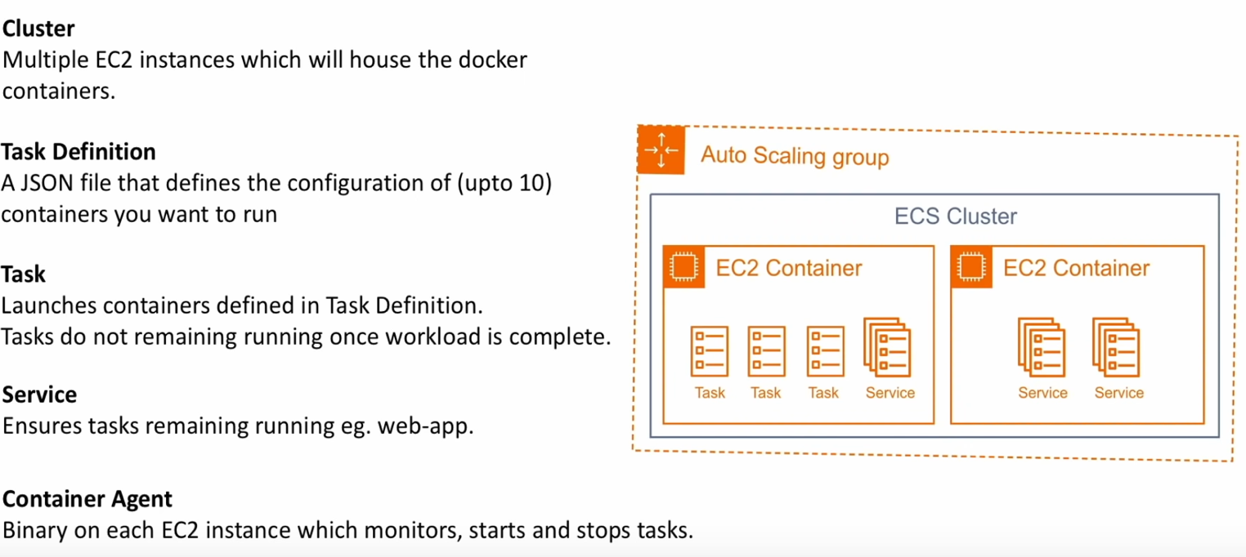

* 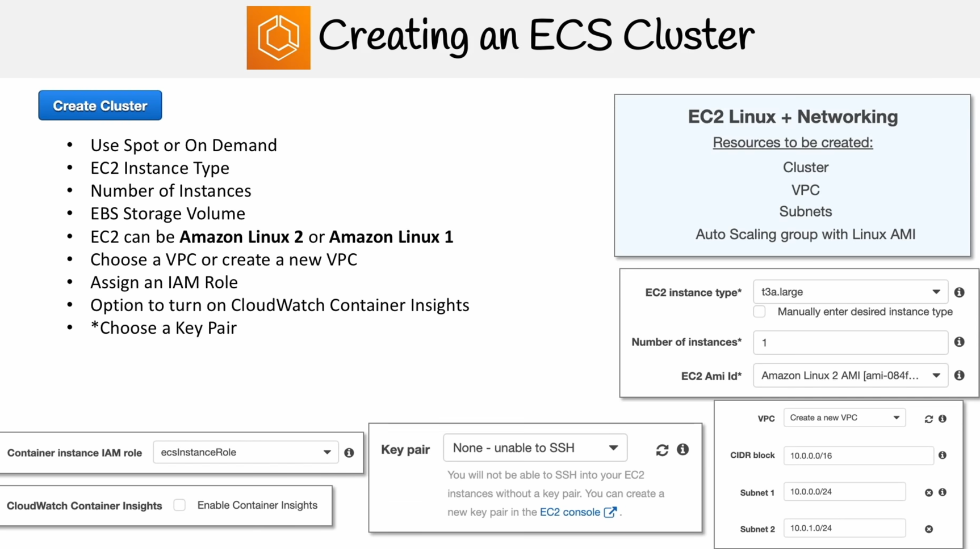

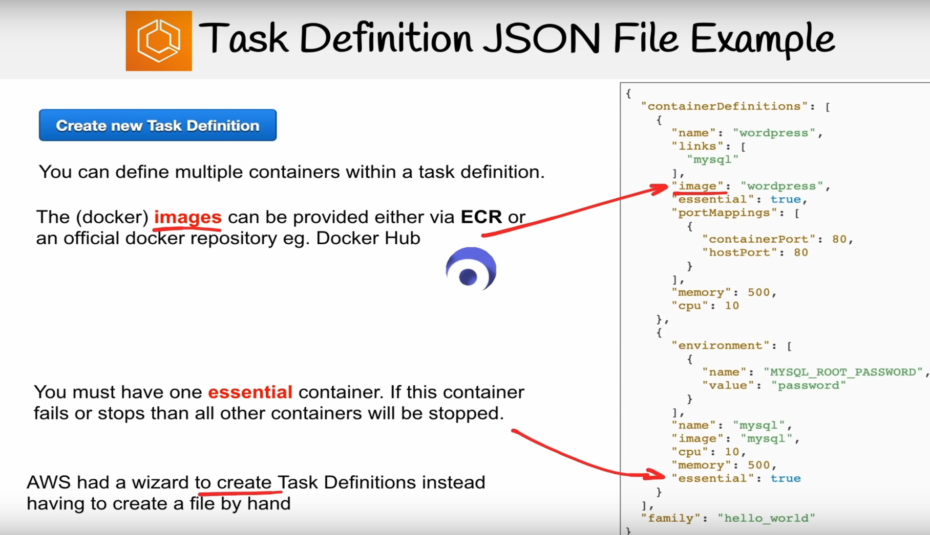

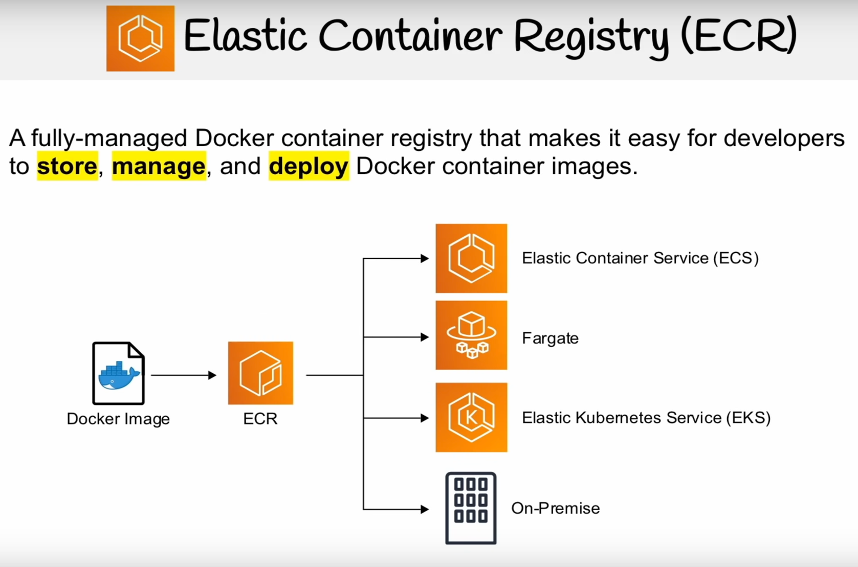

* For creating a ECS cluster, you need to create an IAM role for the EC2 instances. **Amazon ECS Instance Role**. So basically you create a role for EC2 and attach container specific permissions.

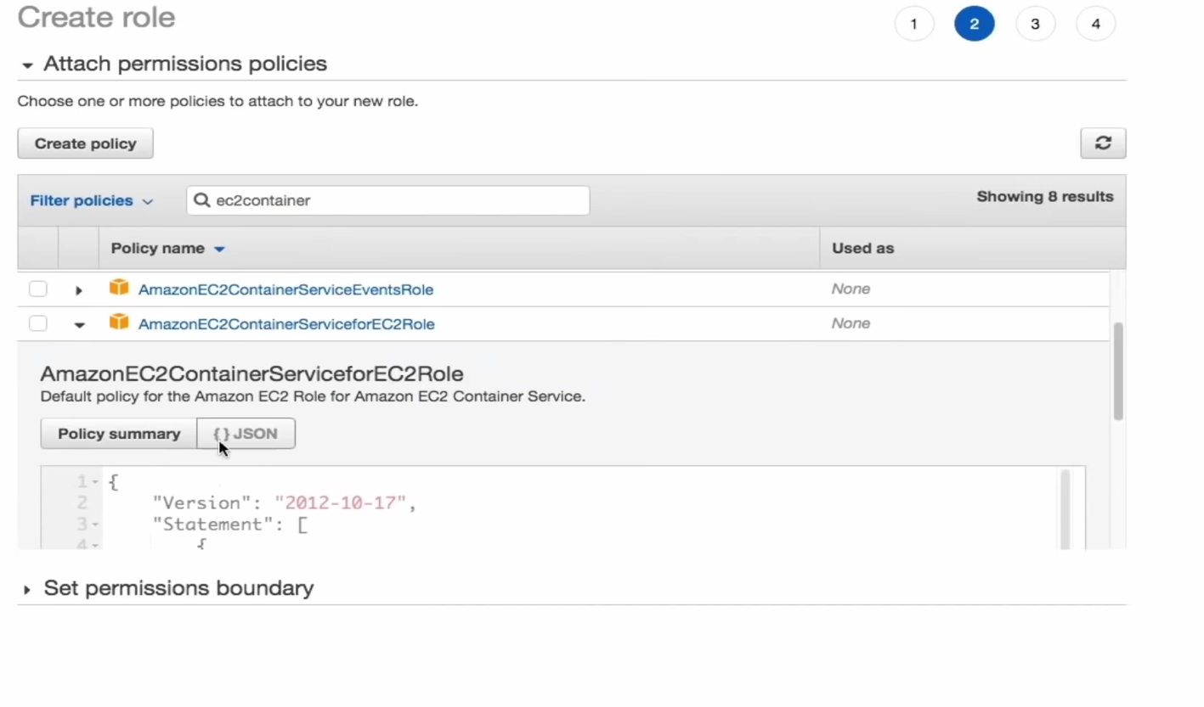

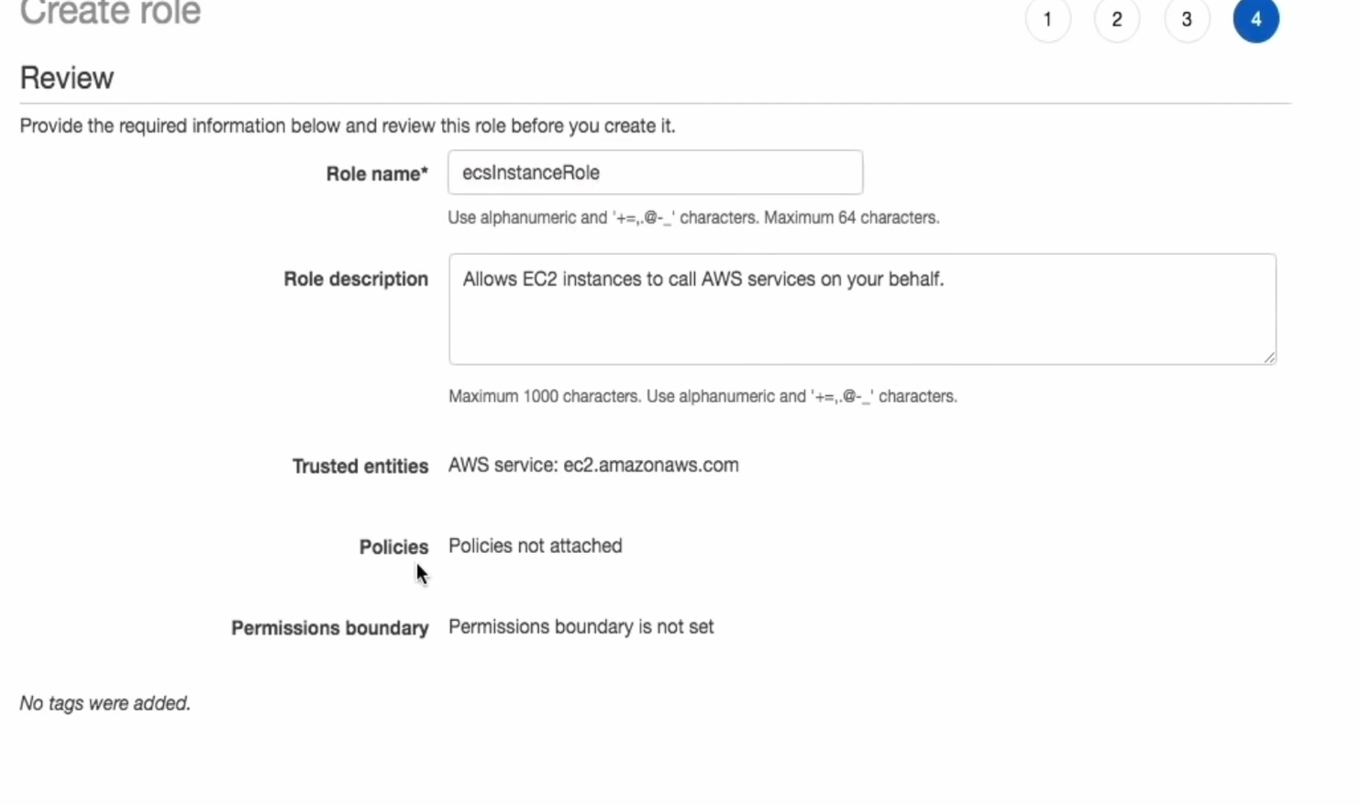

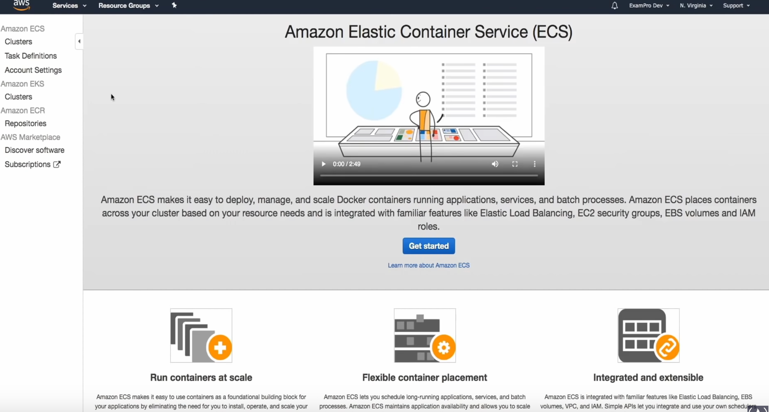

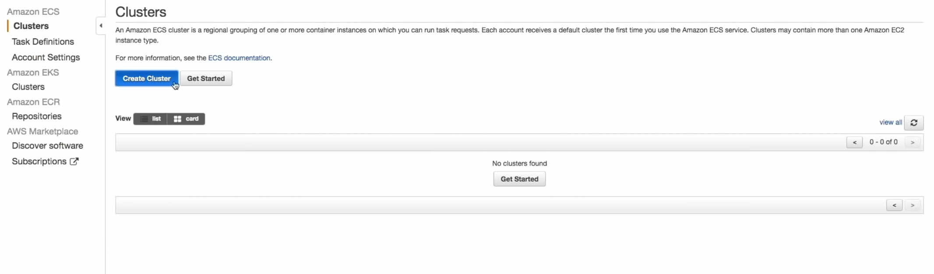

* Select EC2 Linux + Networking

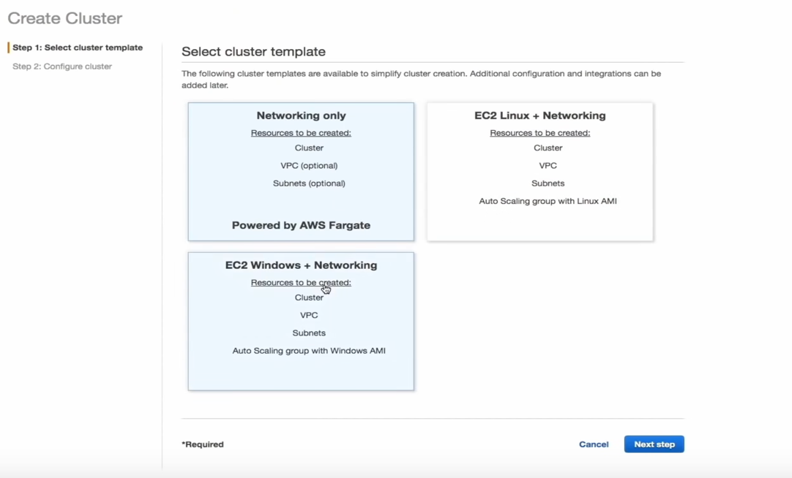

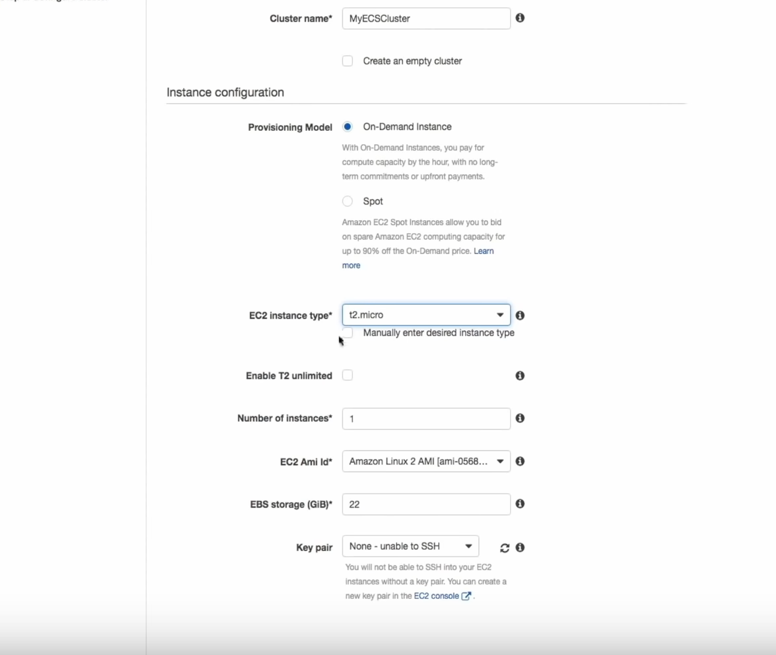

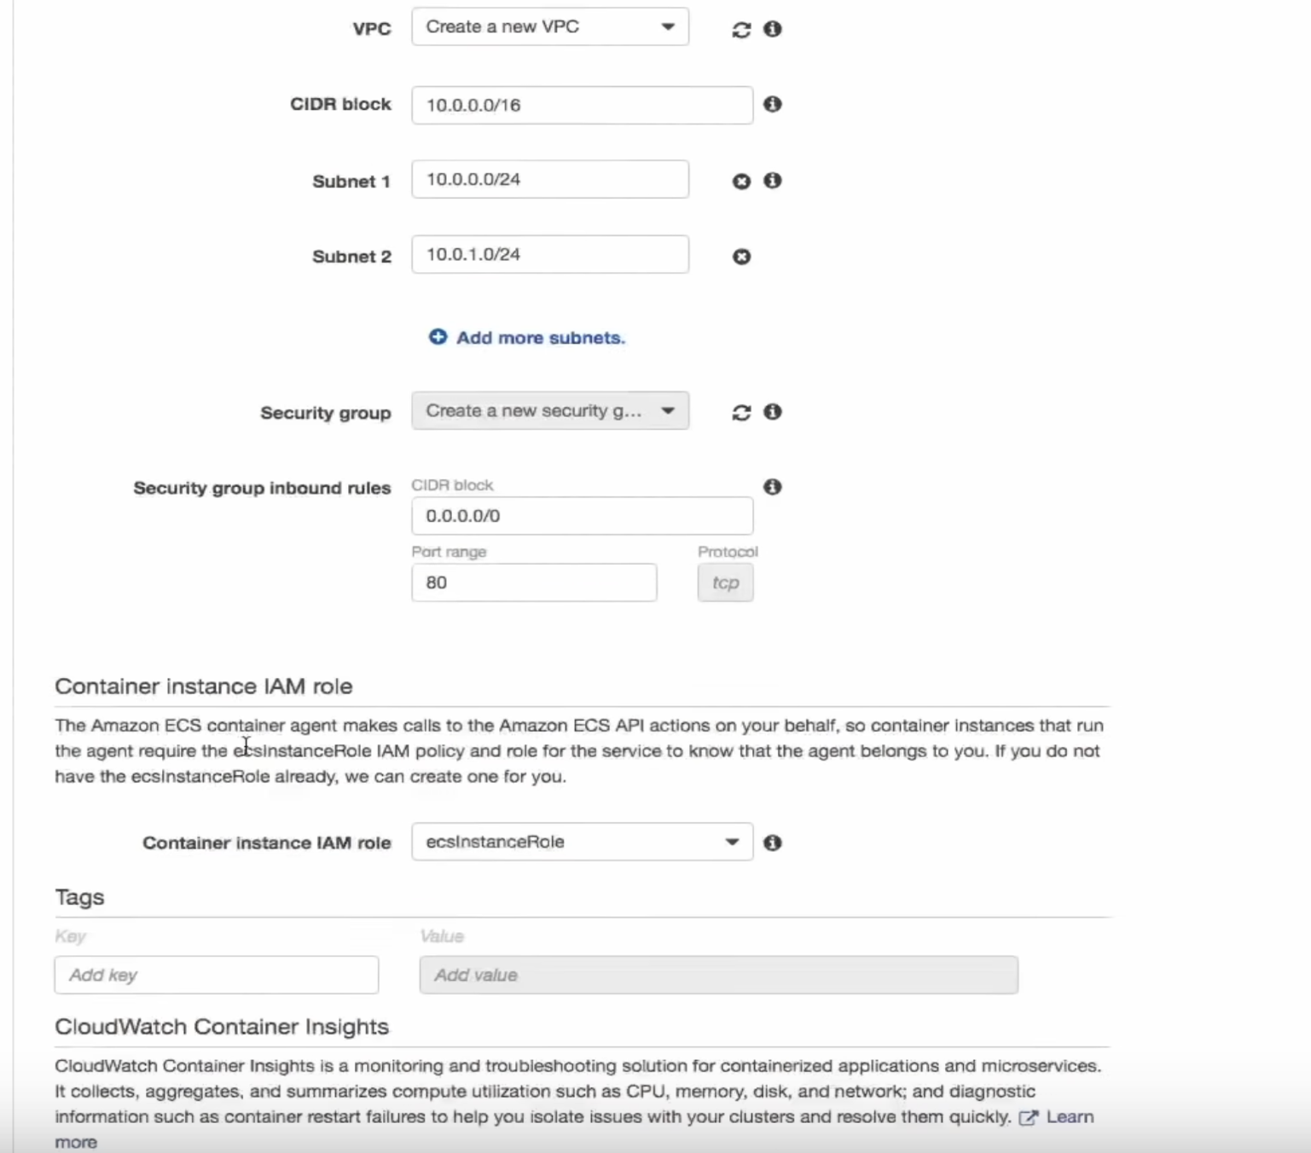

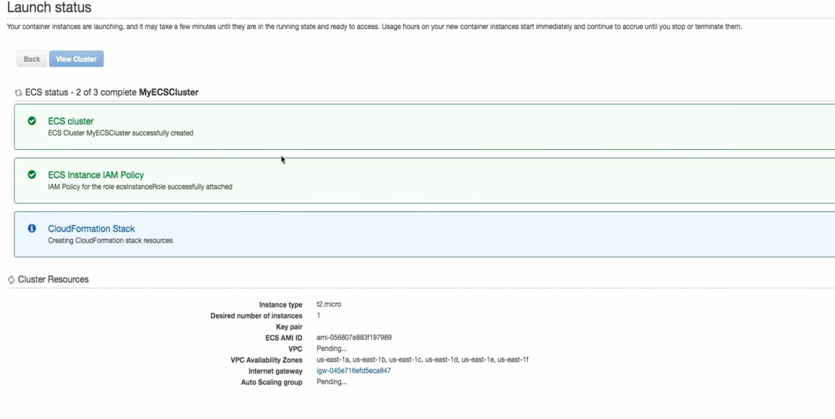

* Now create the task definitions.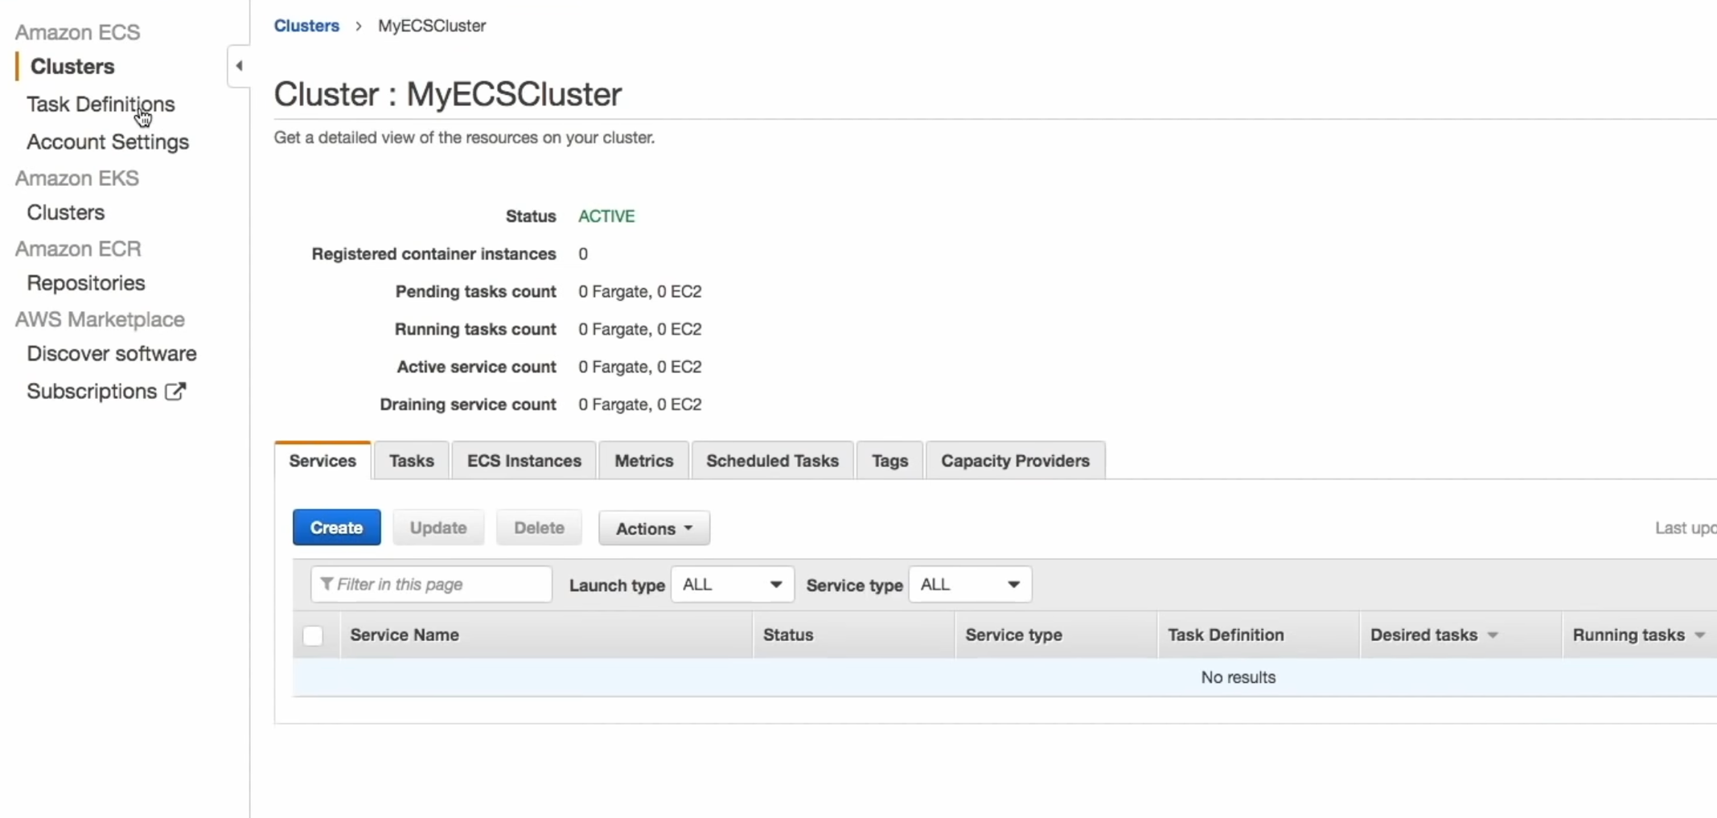

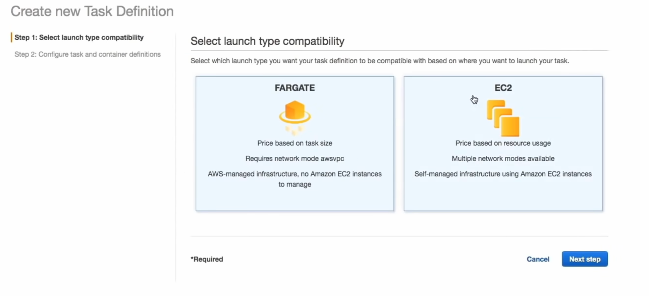

* 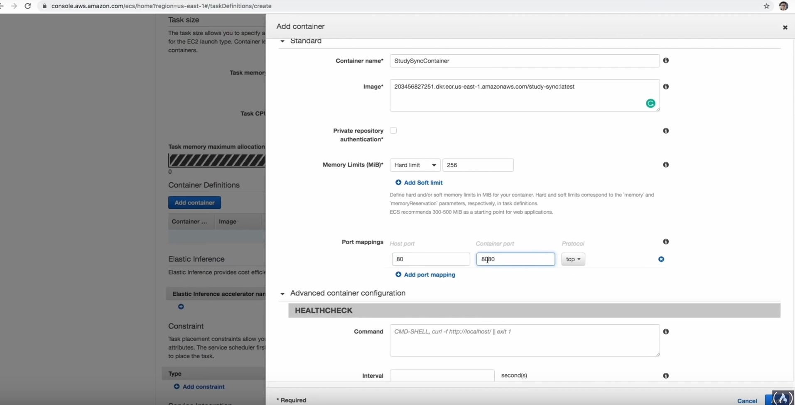

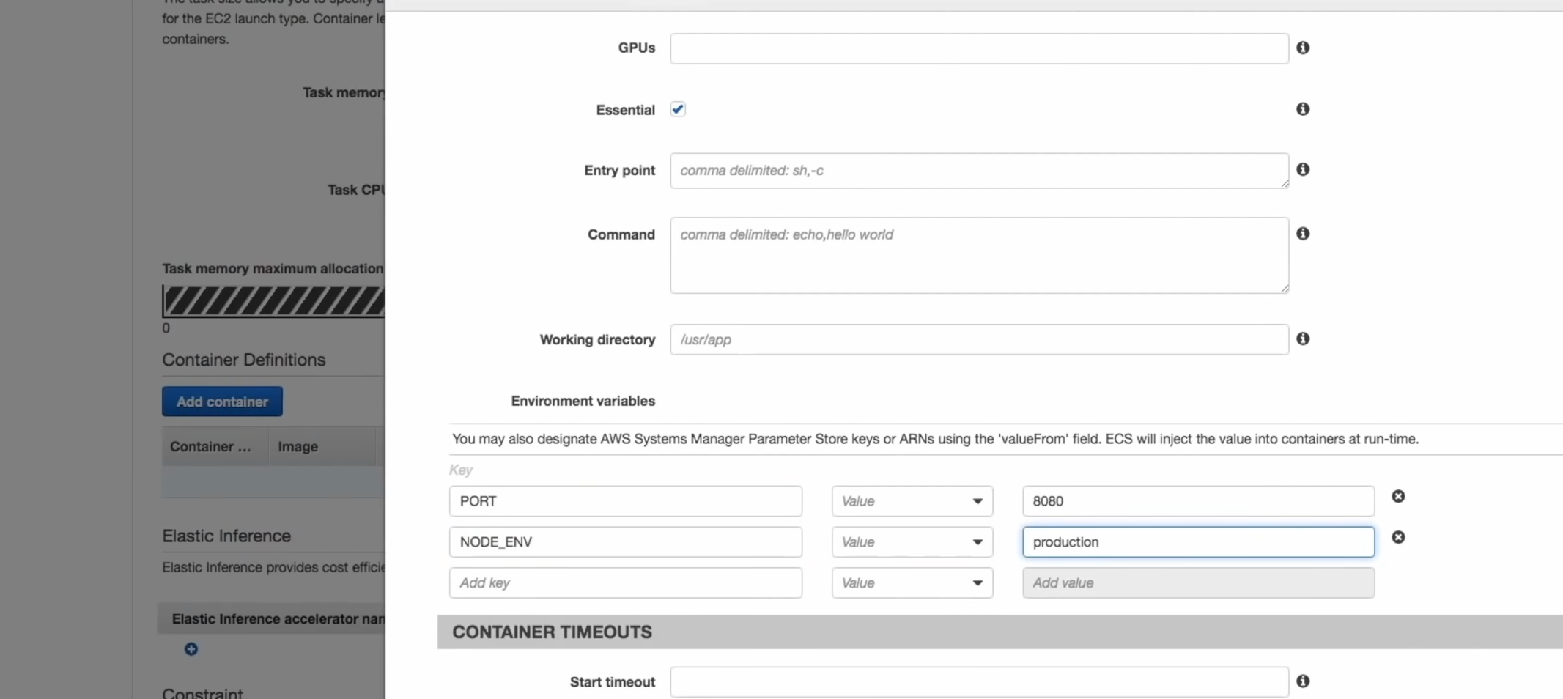

* You also need to create ecsTaskExecutionIam role. Basically an IAM role for the task to access AWS Services.

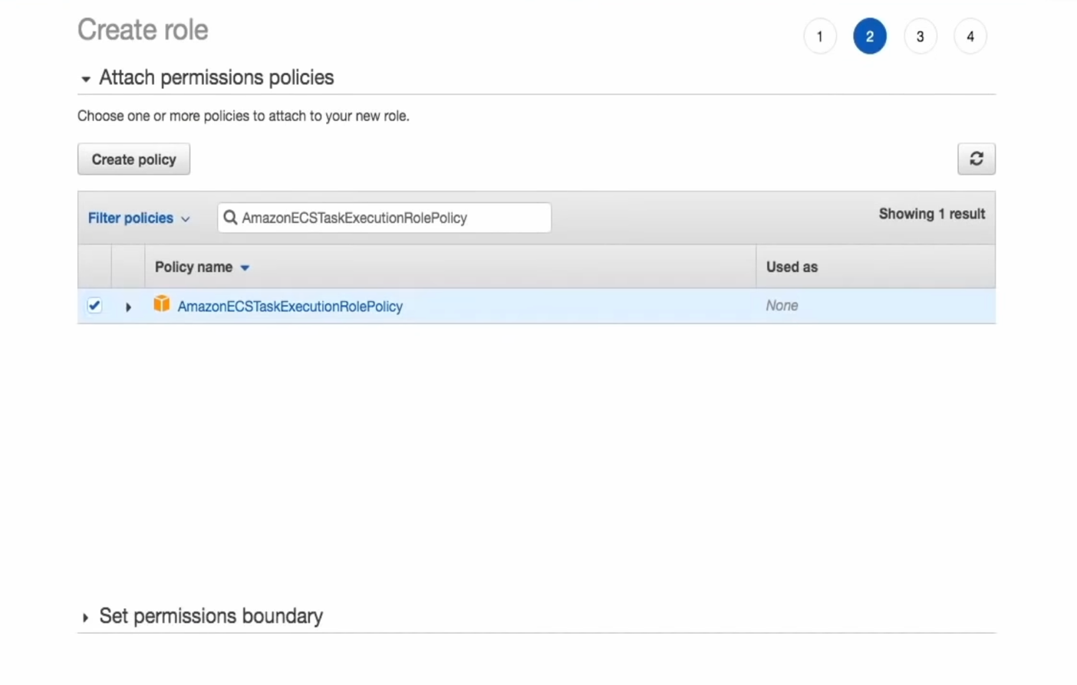

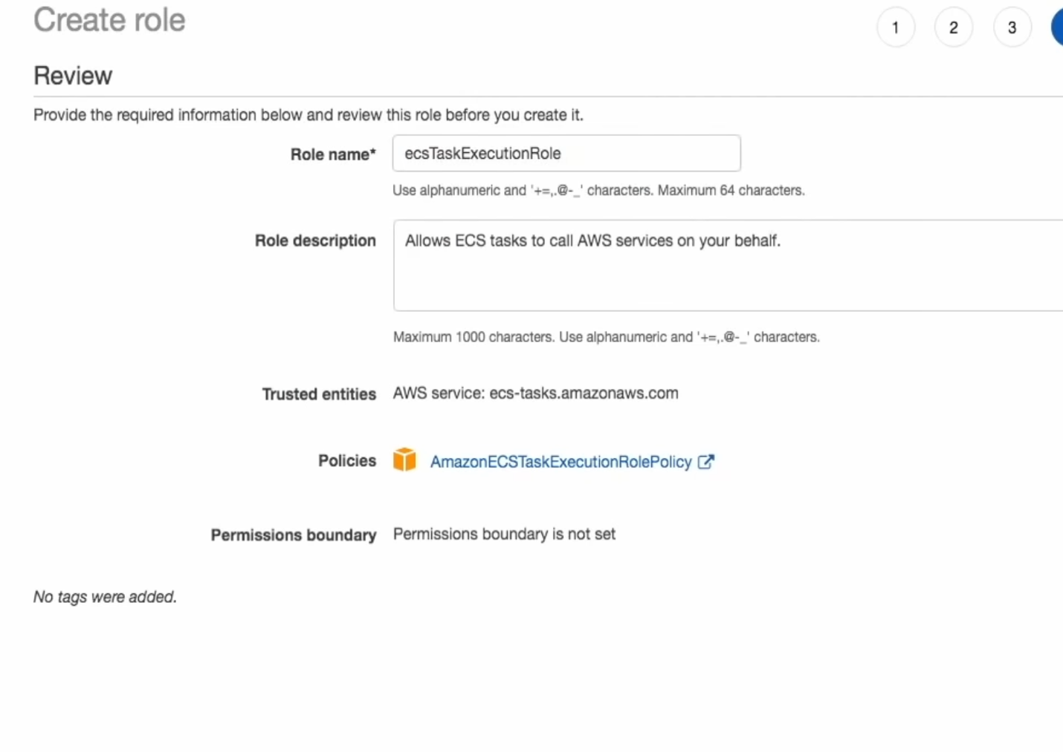

* Now we can create the task definition
* Configure the service as well now – remember service runs all the time and the tasks close once they complete

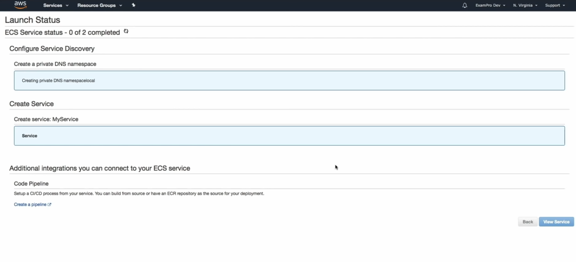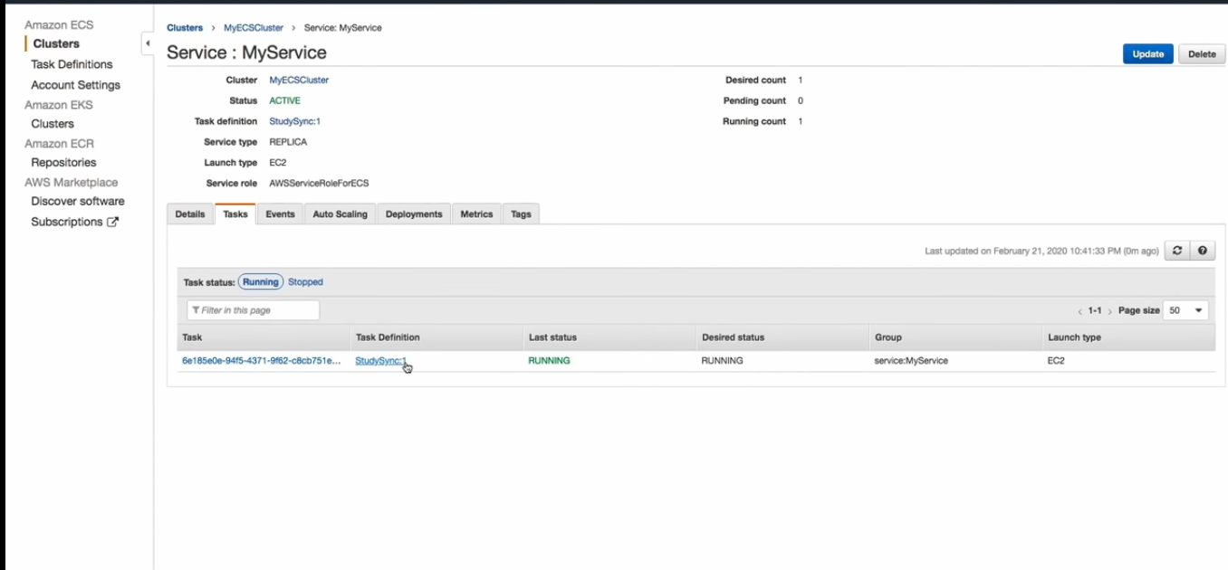

* With Fargate you do not need to provision ECS instances. Just define the task definitions, memory and CPU for the tasks.

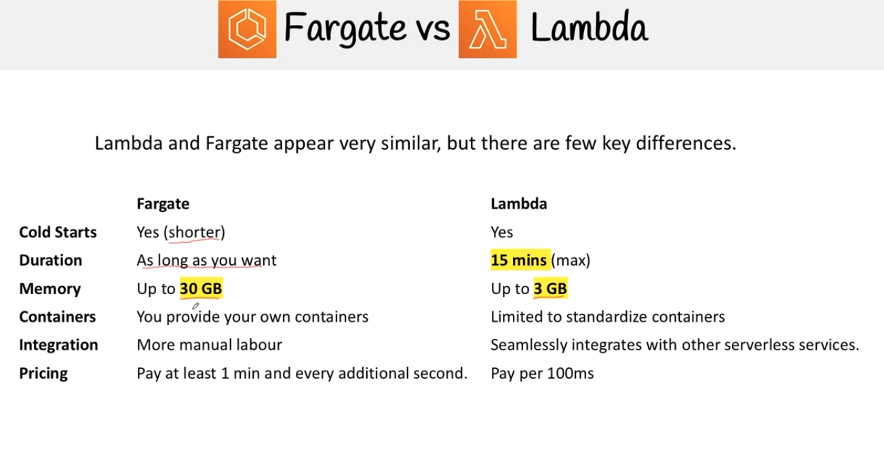

* To create a fargate service, go to ECS and create a cluster and choose “Networking Only” because no EC2 needs to be provisioned.
* Create a new task definition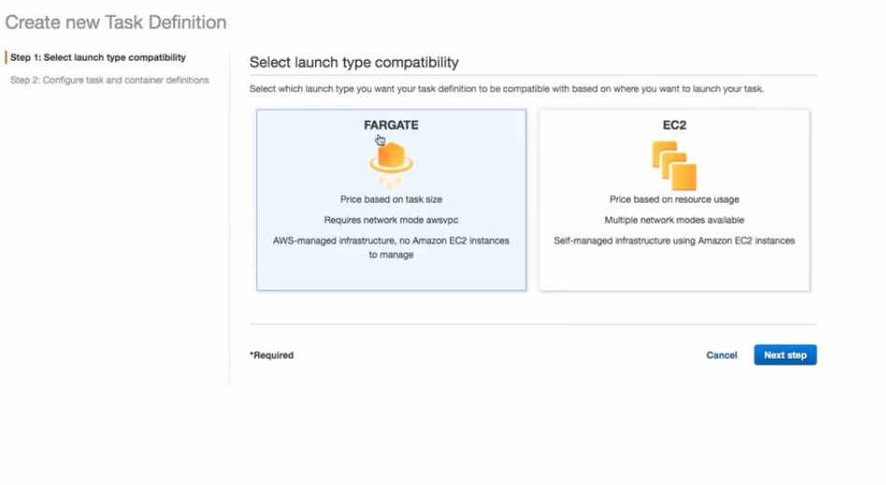

X Ray

* Distriubuted tracing System

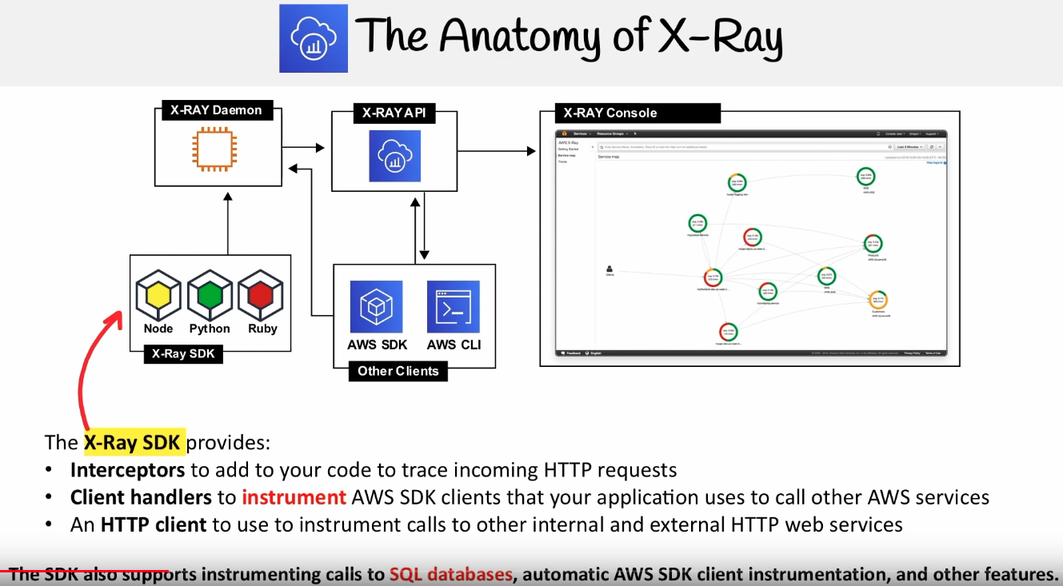

ACM

* Creates and manages certificates for AWS based websites. Attaches to ELB, Cloudfront, API Gateway ad Elastic Beanstalk  
  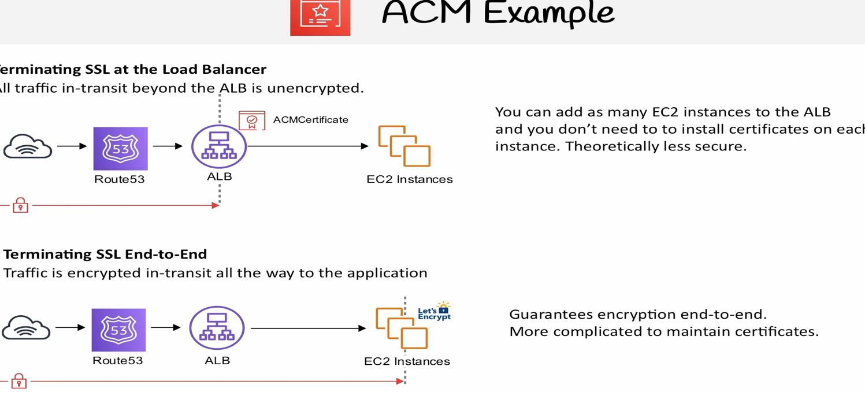

Route53

* Register and maintain domains

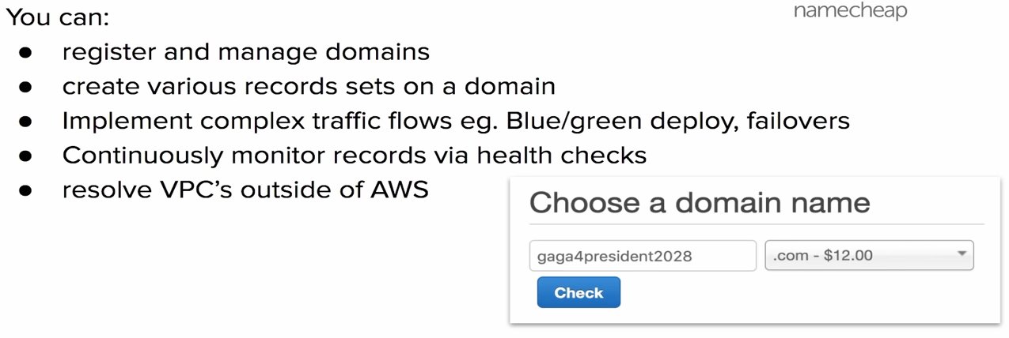

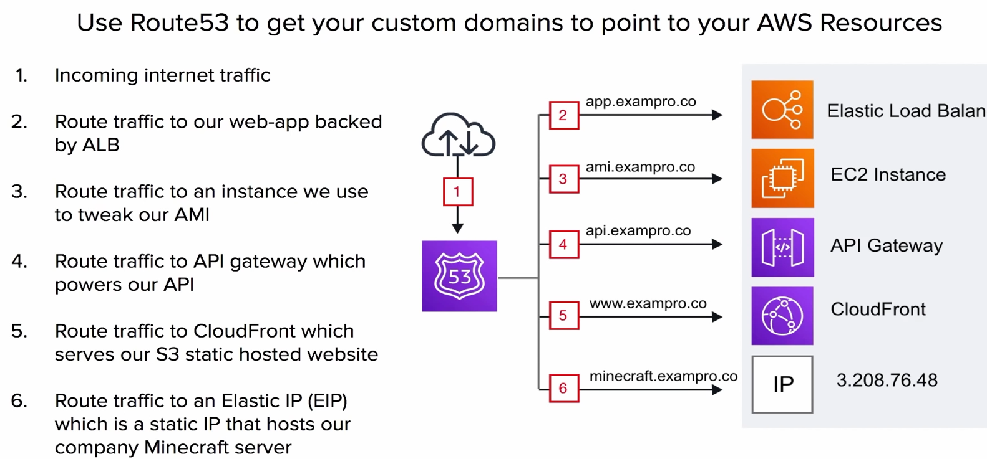

AWS CLI

* For programmatic access, you need to have access key id and secret key. You can store them in ~/.aws/credentials and group them by profiles if you have multiple users. Users can be created from IAM console.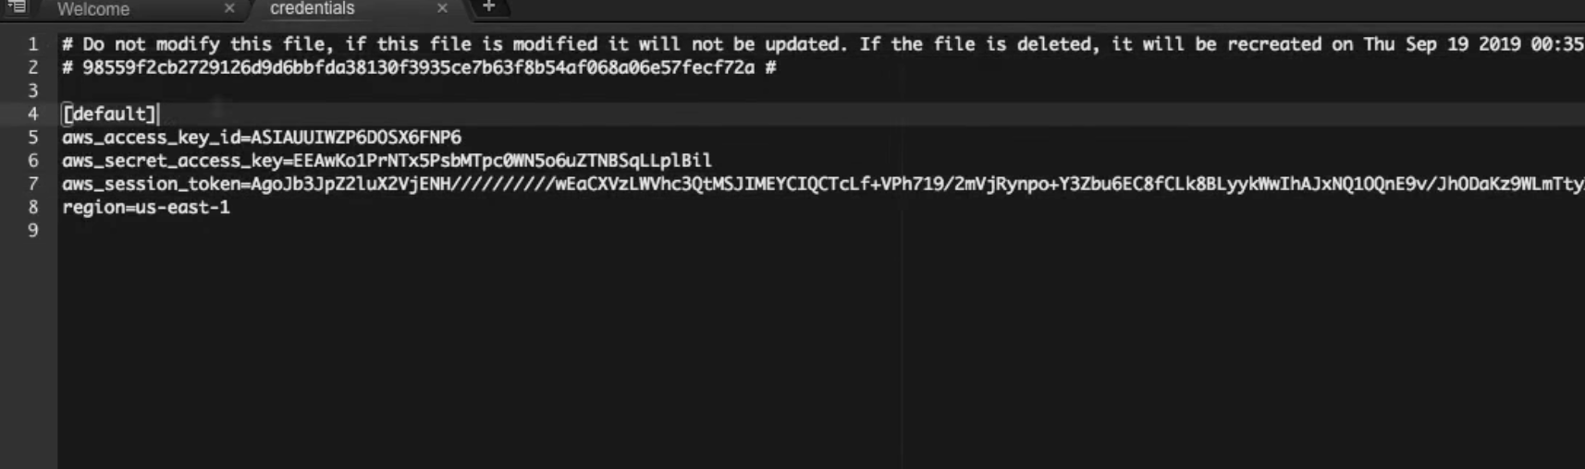
* List of buckets for a particular user

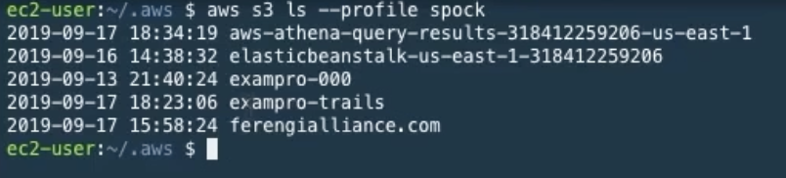

* aws s3 cp s3://<path on s3> <destPath> --profile spock -> copy from s3

AWS SDK

* Gemfile to speficy revelant SDK’s for Ruby. Then you can use bundle install to download them
* 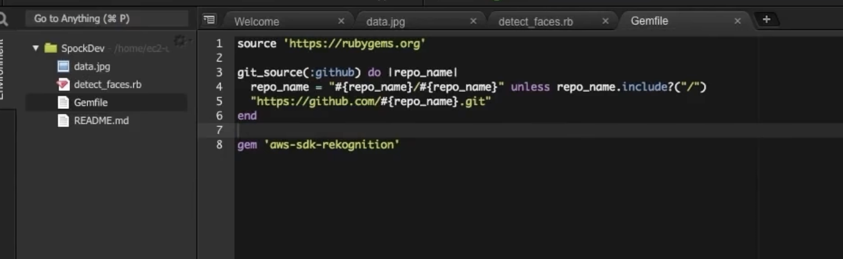

KMS:

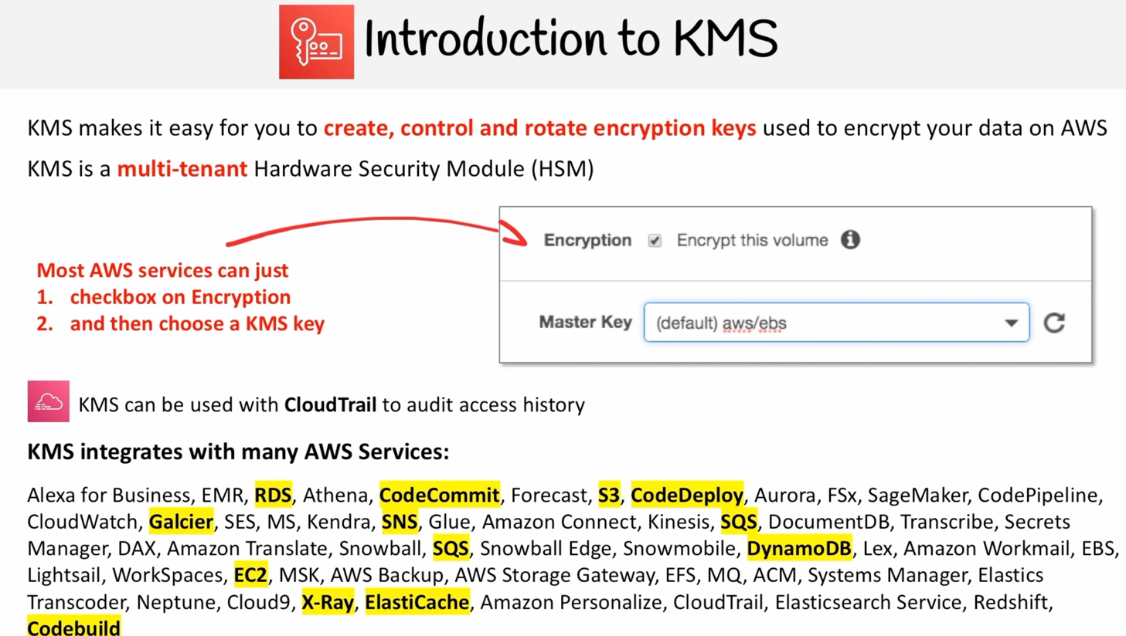

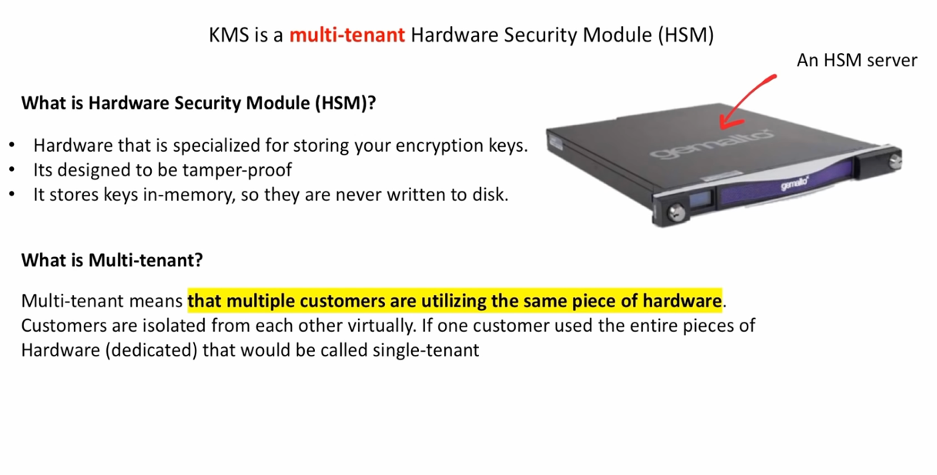

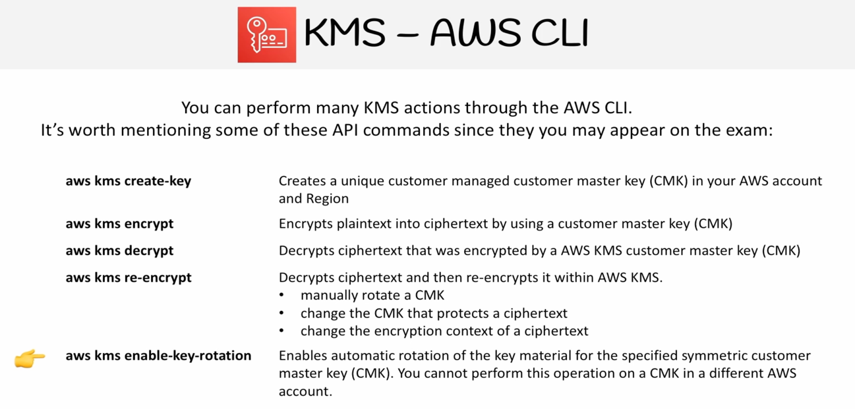

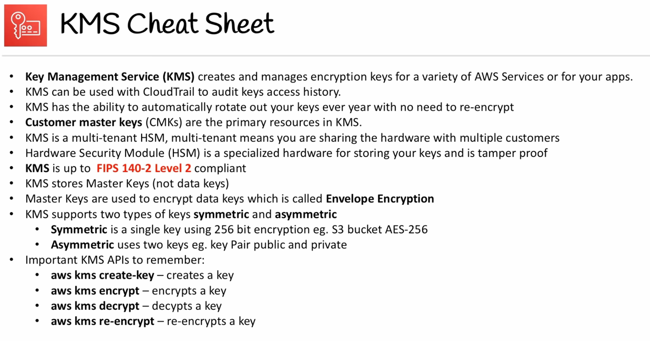

Cognito:

* 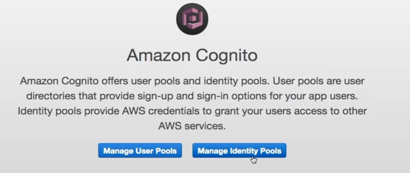

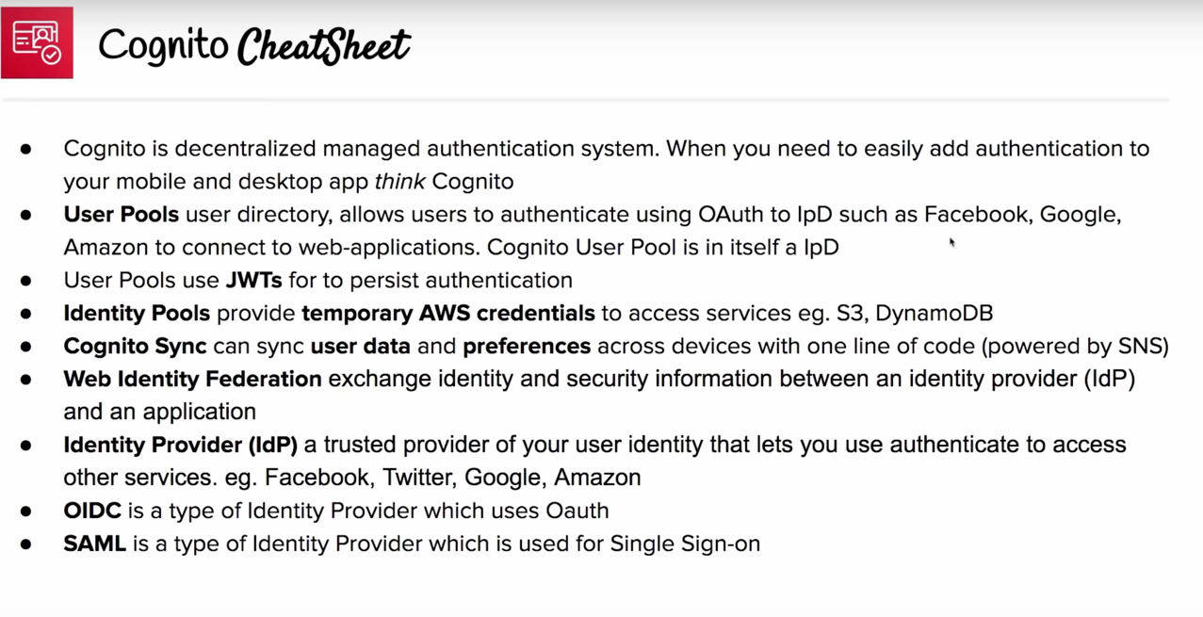

SNS

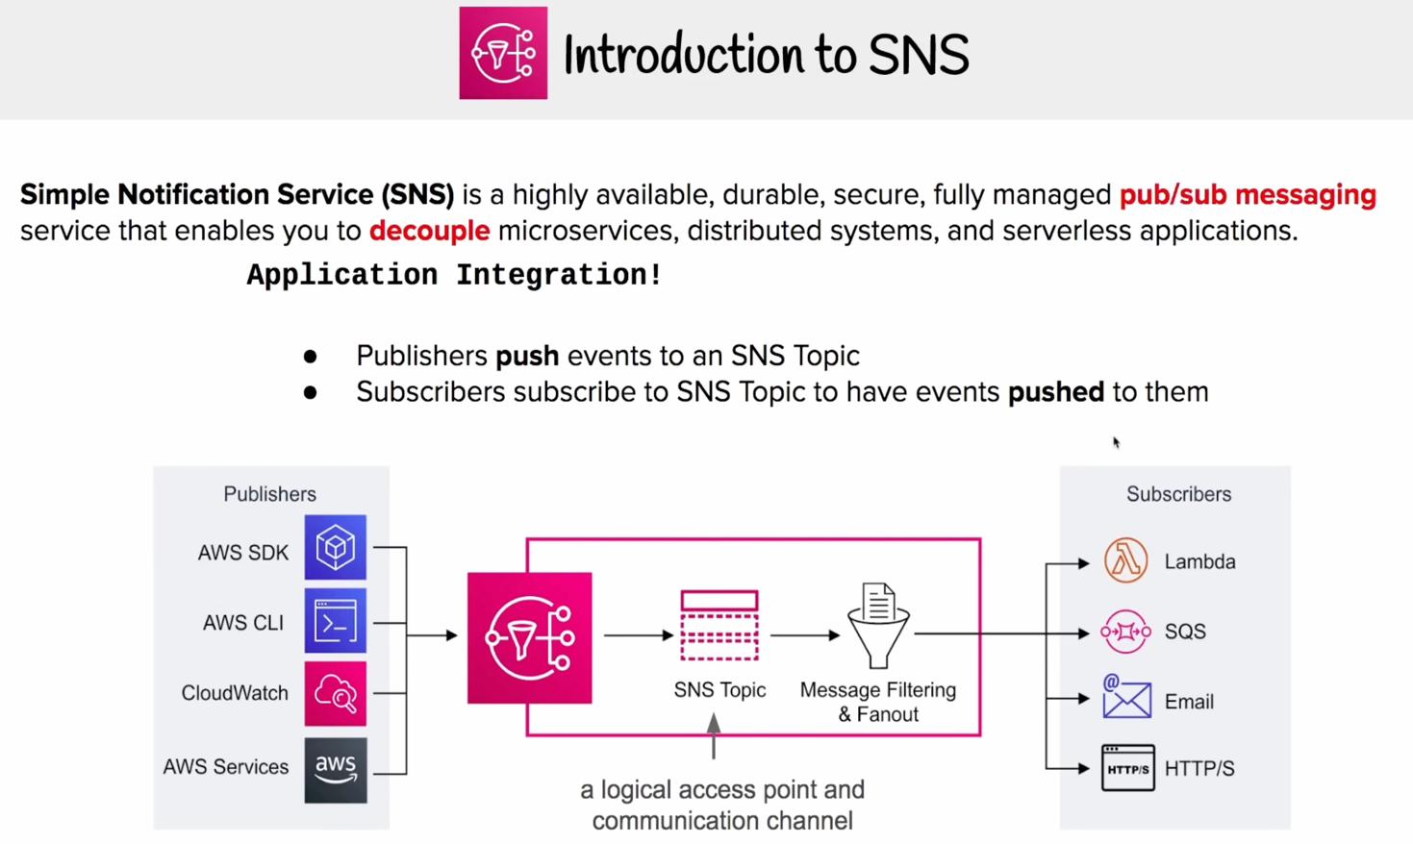

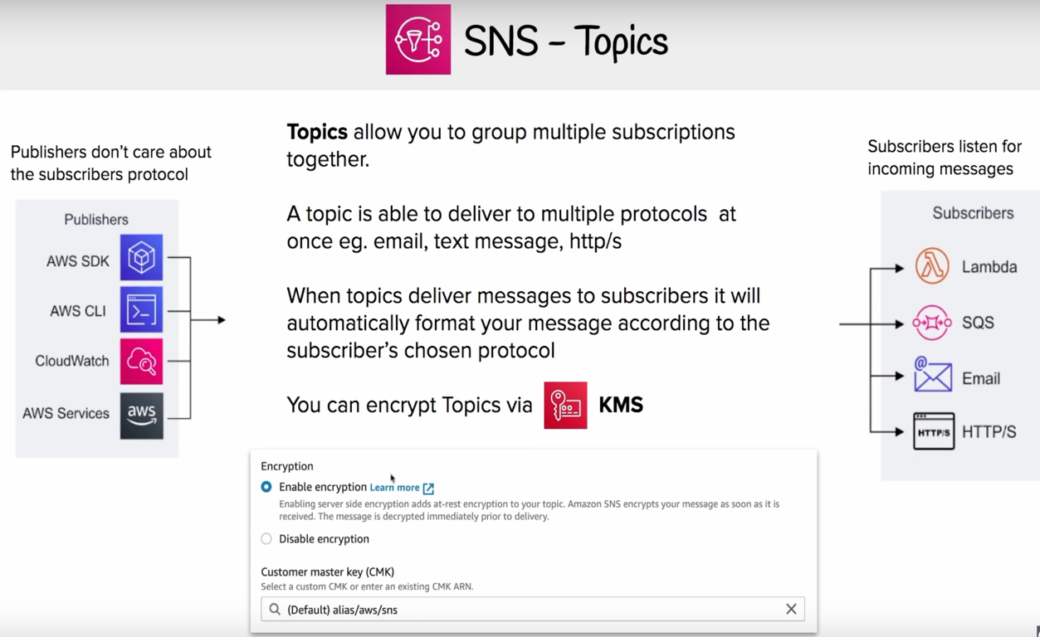

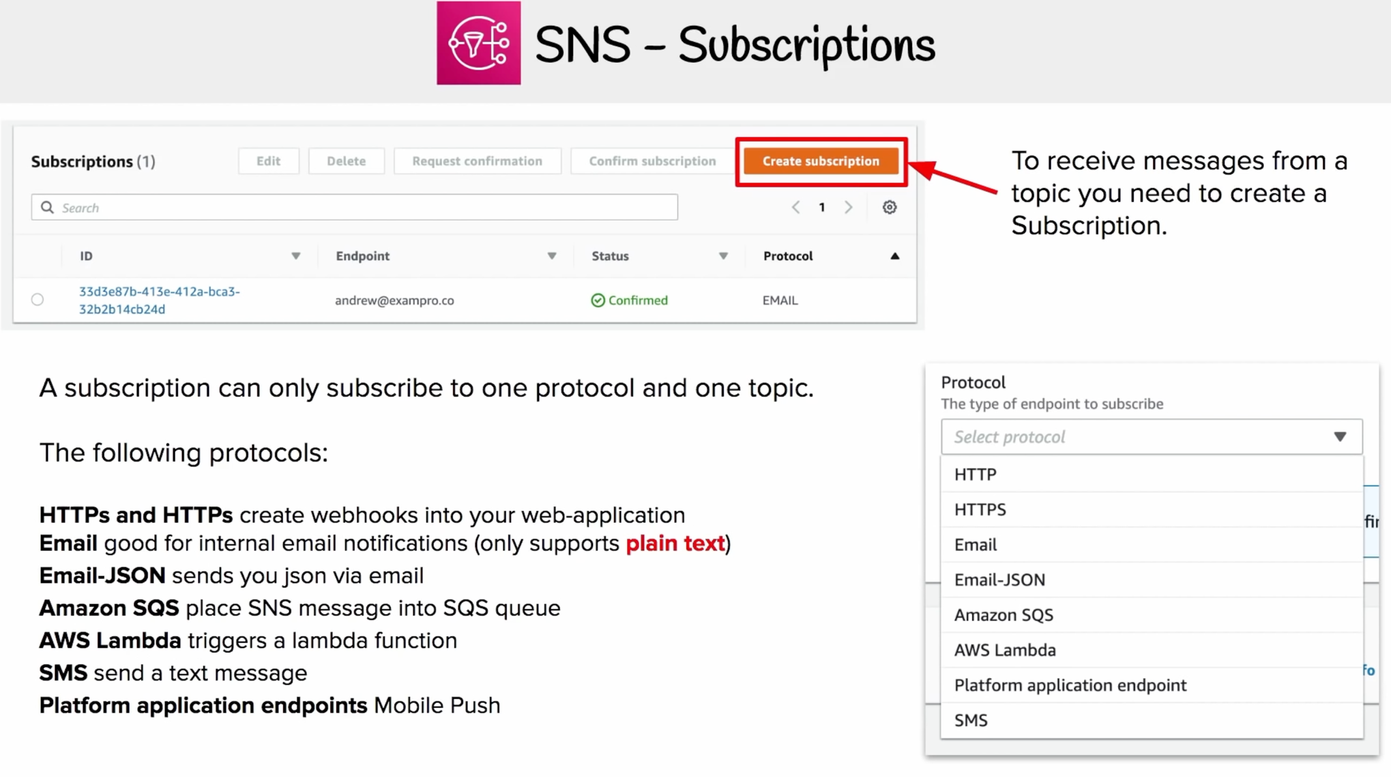

SQS

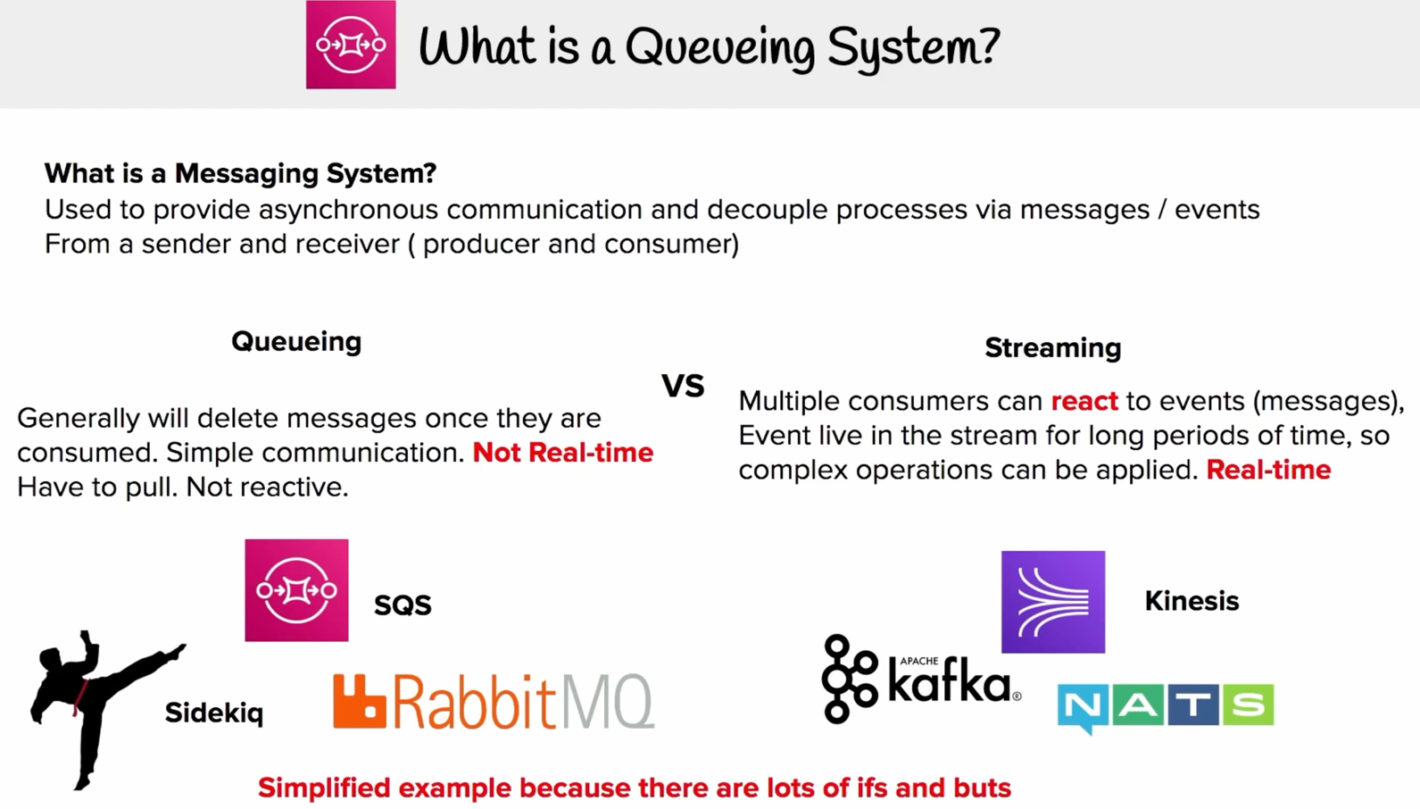

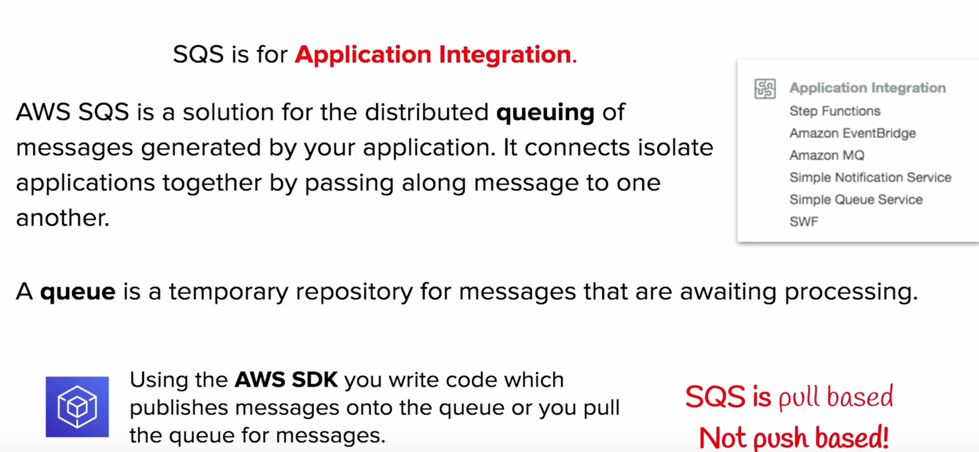

Kinesis:

* Like Kafka for “streaming events”

